Challenges 08

Challenge 1: Hiring-App
Repository: https://github.com/betawins/hiring-app.git
Stages Required:
- Git Clone
- SonarQube Analysis
- Maven Build
- Nexus Upload
- Slack Notification
Objective
Create a Jenkins Freestyle Job with the following stages:
- Git Clone
- SonarQube Integration
- Maven Compilation
- Nexus Artifactory Upload
- Slack Notification
Prerequisites
- Jenkins Server running on Port 8081
- Java 21 Installed
- Git Installed
- Maven Installed
- Docker Installed
- SonarQube Container Running on Port 9000
- Nexus Container Running on Port 8082
- Slack Webhook Configured
- SonarQube Token Created
- Nexus Repository Created
Execution Steps
- Started SonarQube Docker container and verified access on Port 9000.
- Started Nexus Docker container and verified access on Port 8082.
- Created Maven Hosted Repository (maven-releases) in Nexus Repository Manager.
- Added SonarQube token, Nexus credentials, and Slack webhook credentials in Jenkins.
- Created a Jenkins Freestyle Job named Hiring-App
- Configured Git SCM with repository https://github.com/betawins/hiring-app.git.
- Configured SonarQube Scanner for code quality analysis.
- Configured Maven build with goal clean package.
- Generated WAR artifact successfully using Maven.
- Uploaded WAR artifact to Nexus Repository Manager.
- Configured Slack integration for build notifications.
- Verified successful notifications in #jenkins-alerts Slack channel.
- Validated Git Clone, SonarQube Analysis, Maven Build, Nexus Upload, Slack Notification.
- Successfully implemented end-to-end CI/CD pipeline using Jenkins Freestyle Job, SonarQube, Maven, Nexus, Slack.
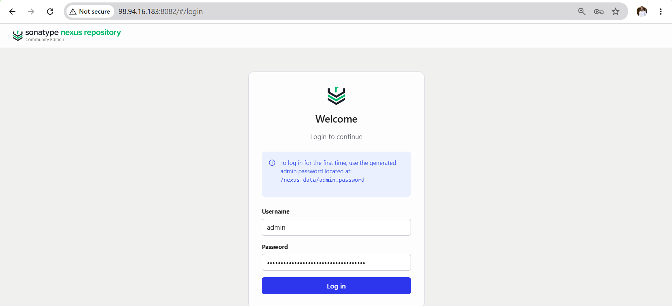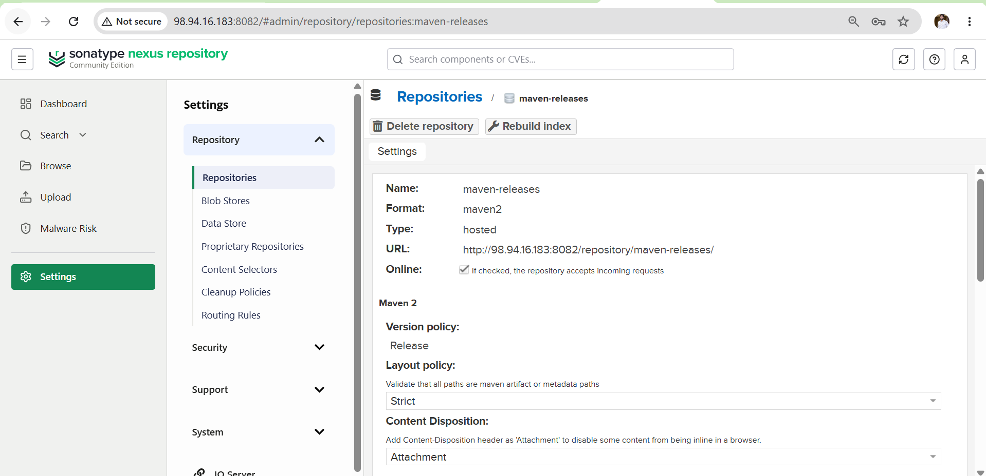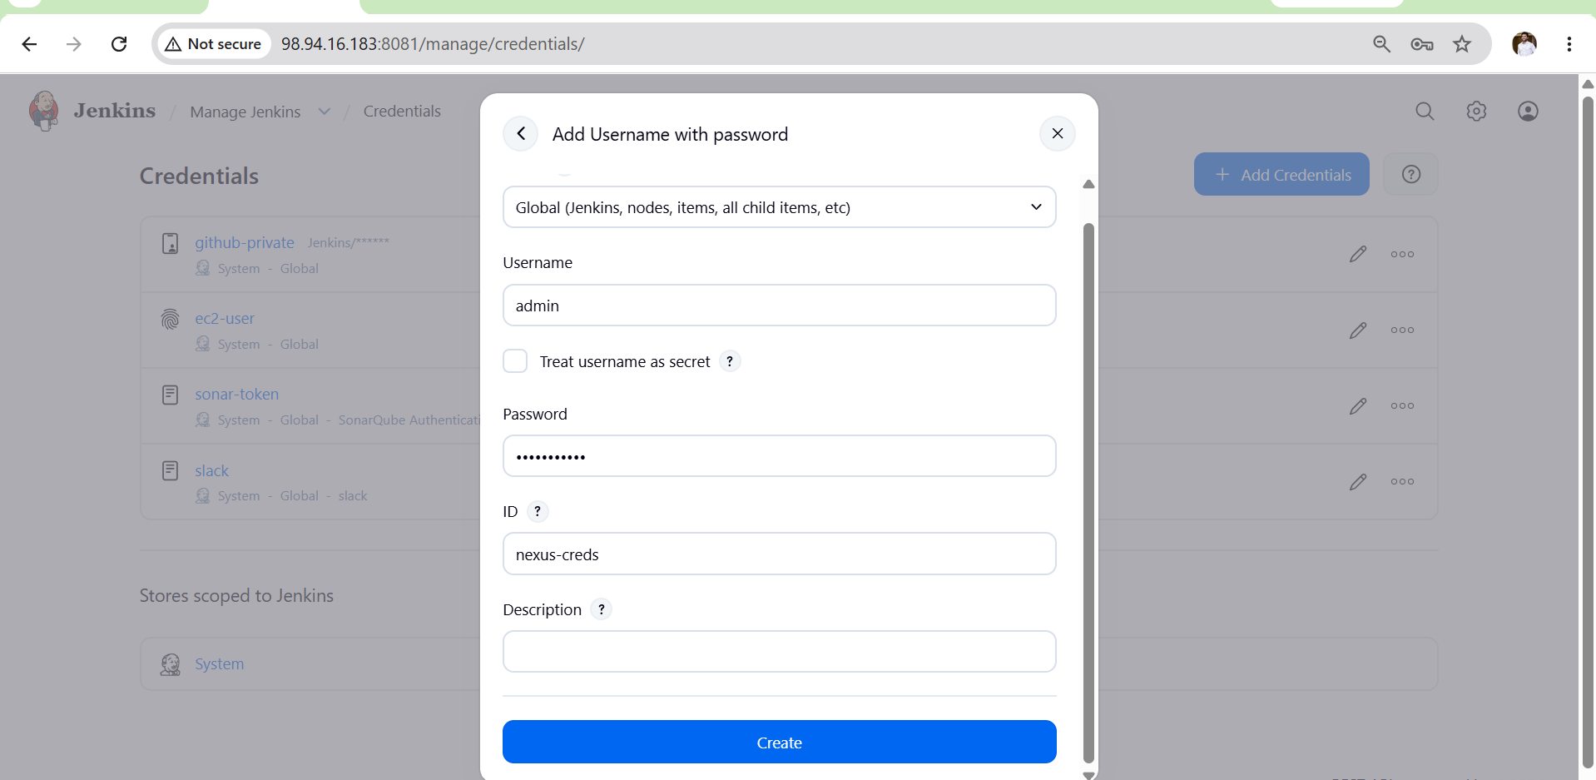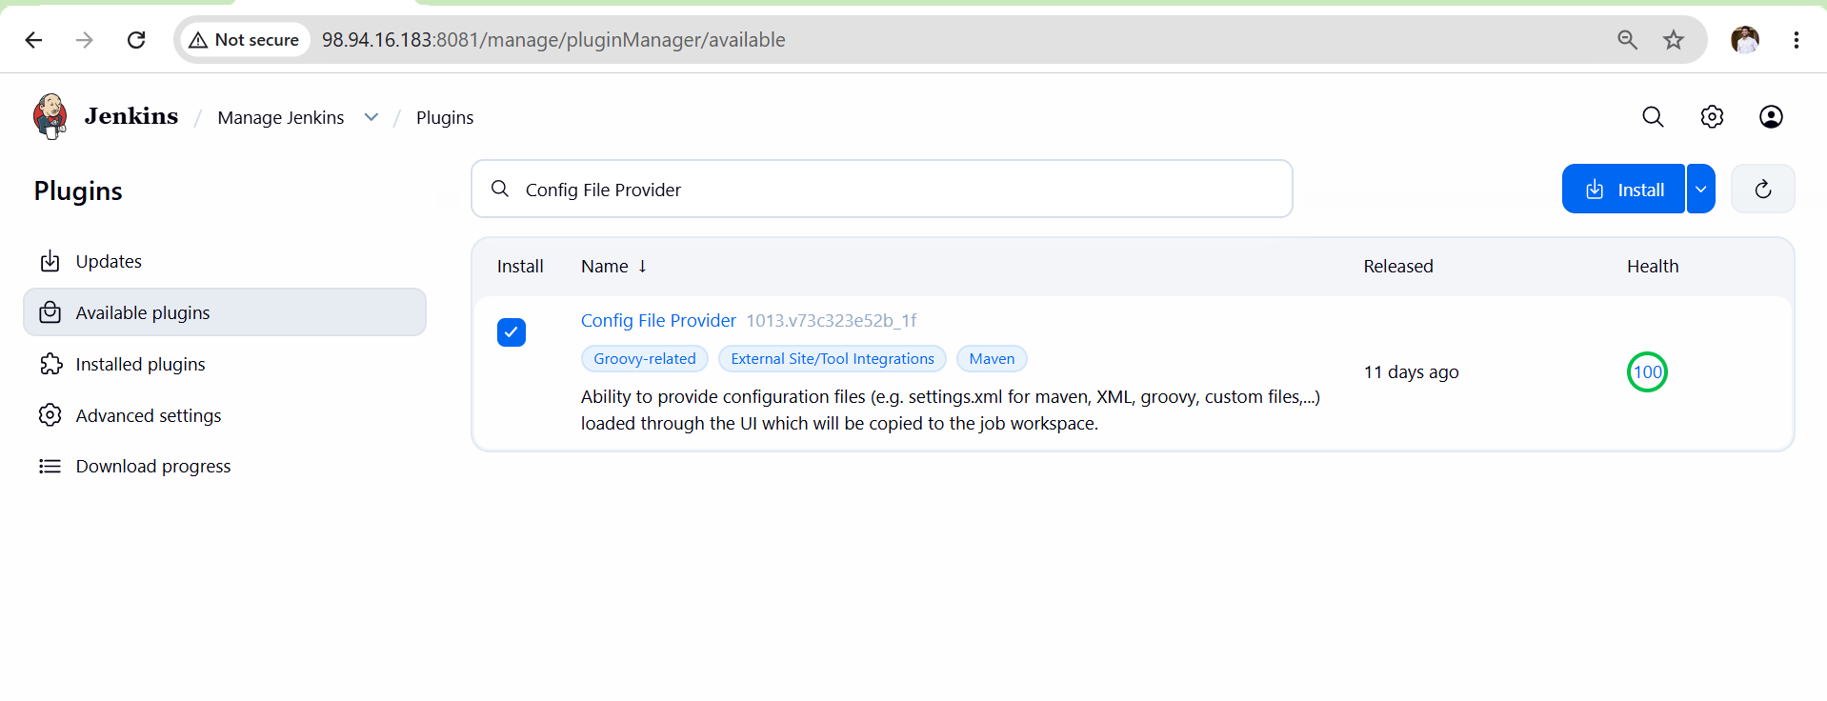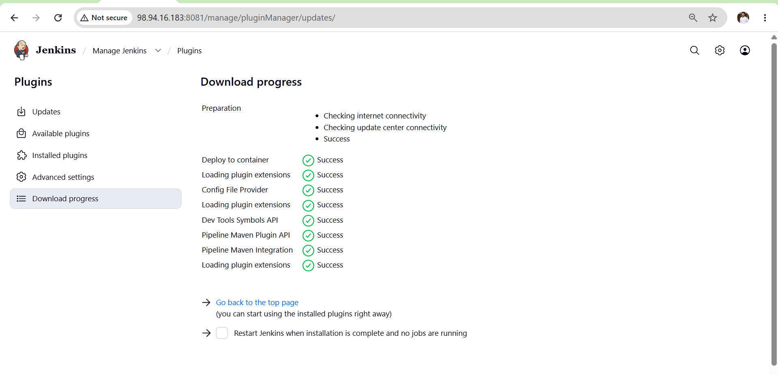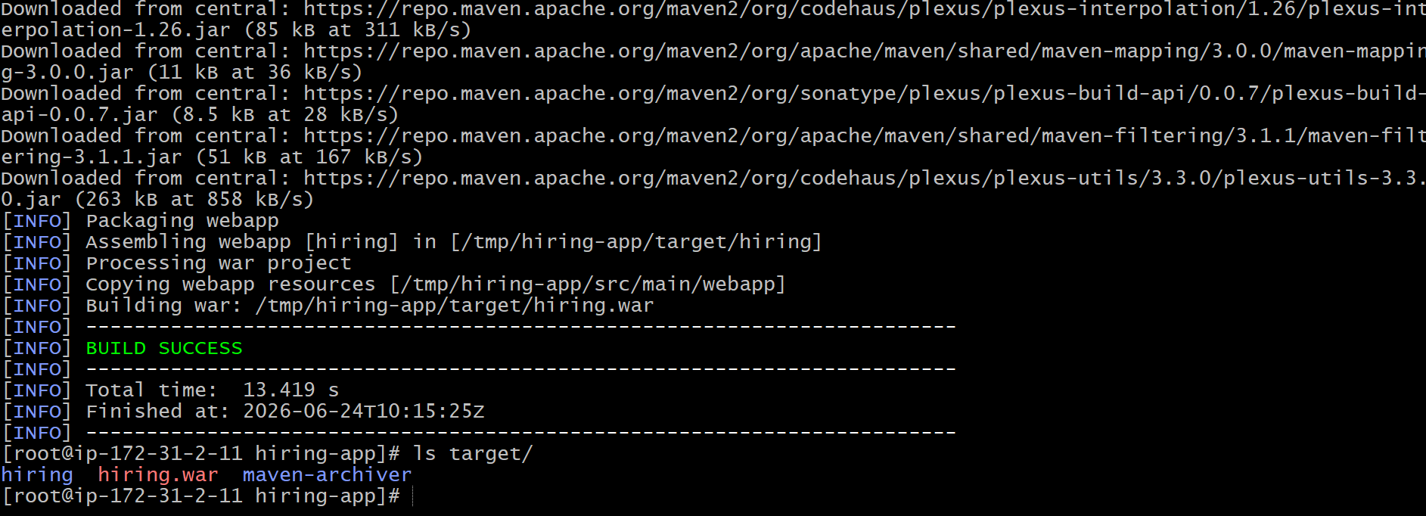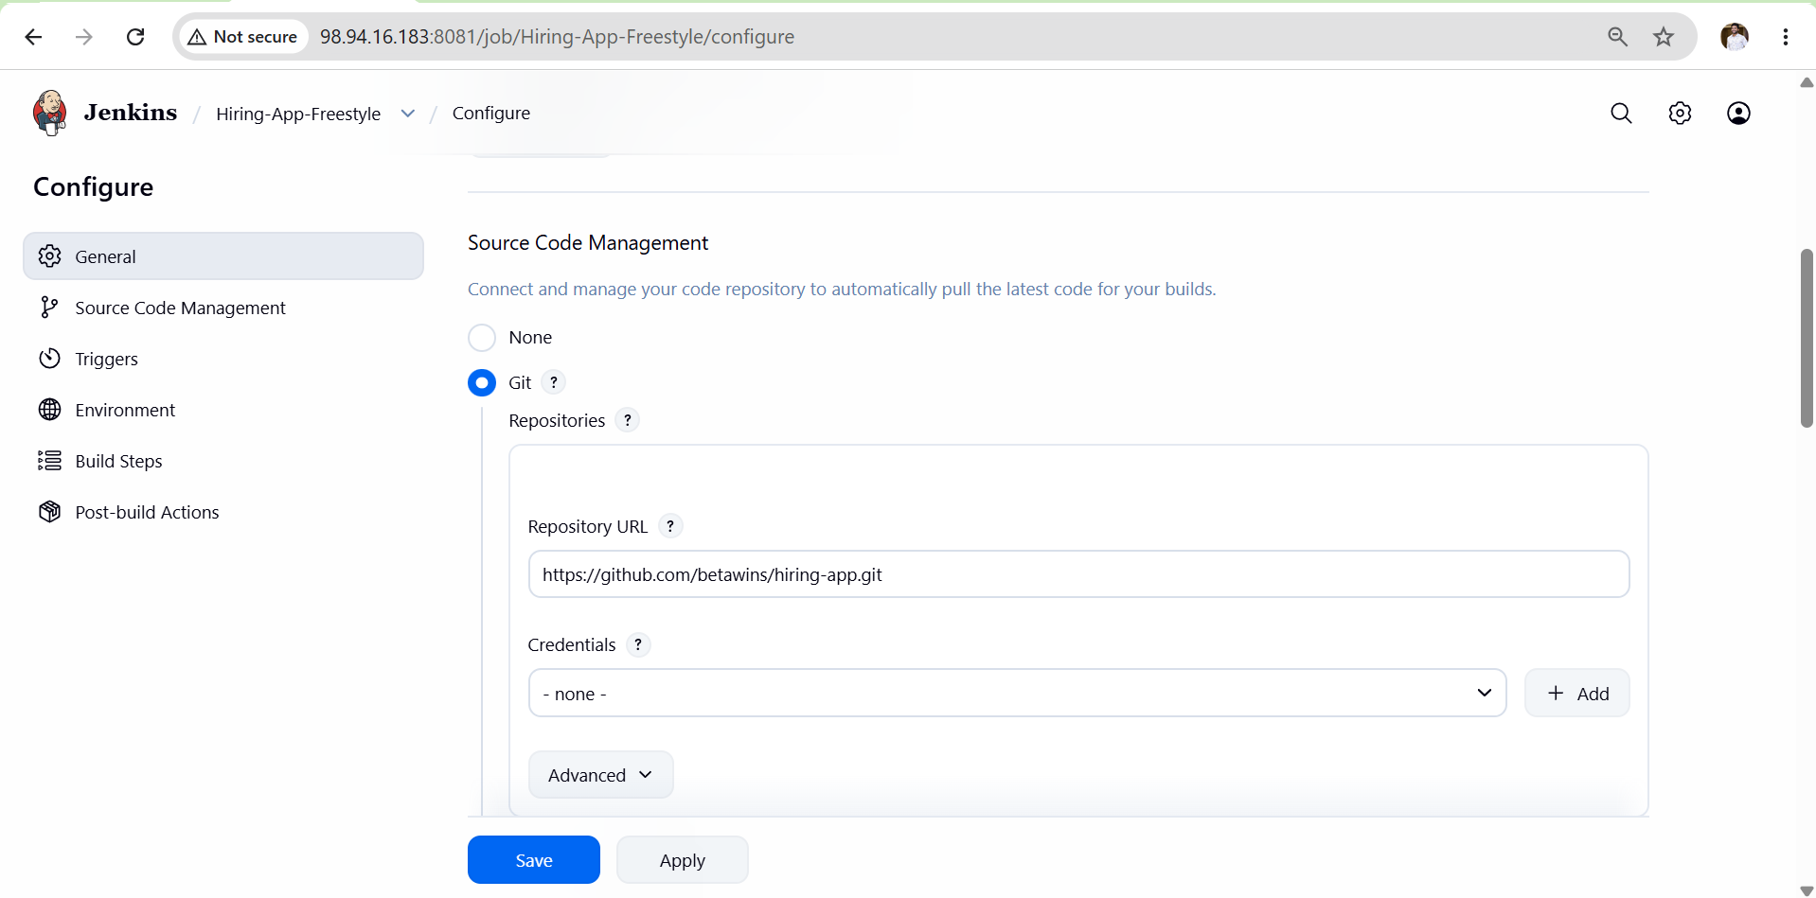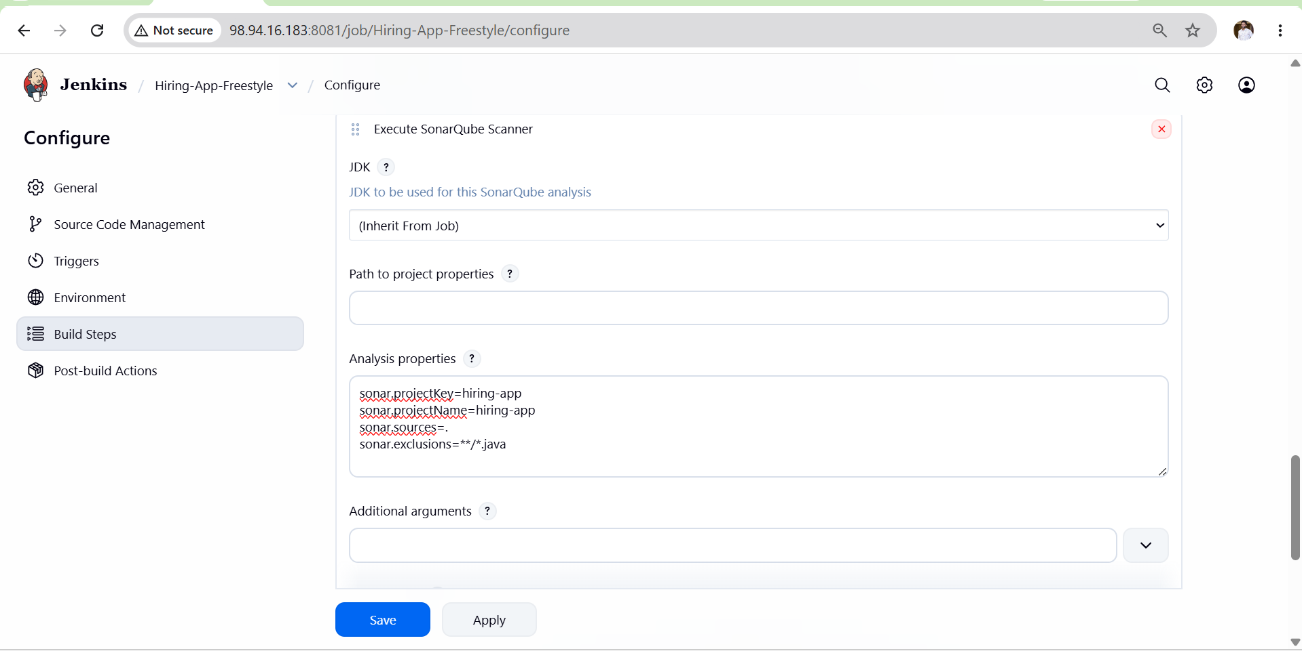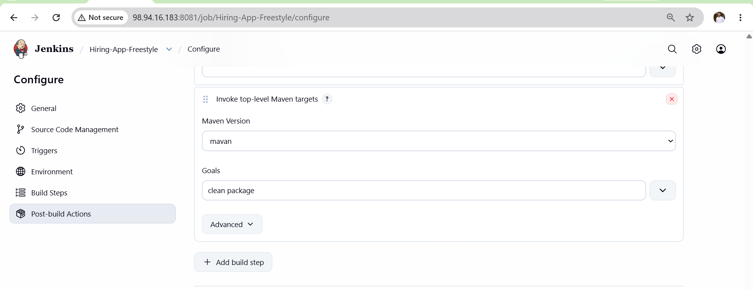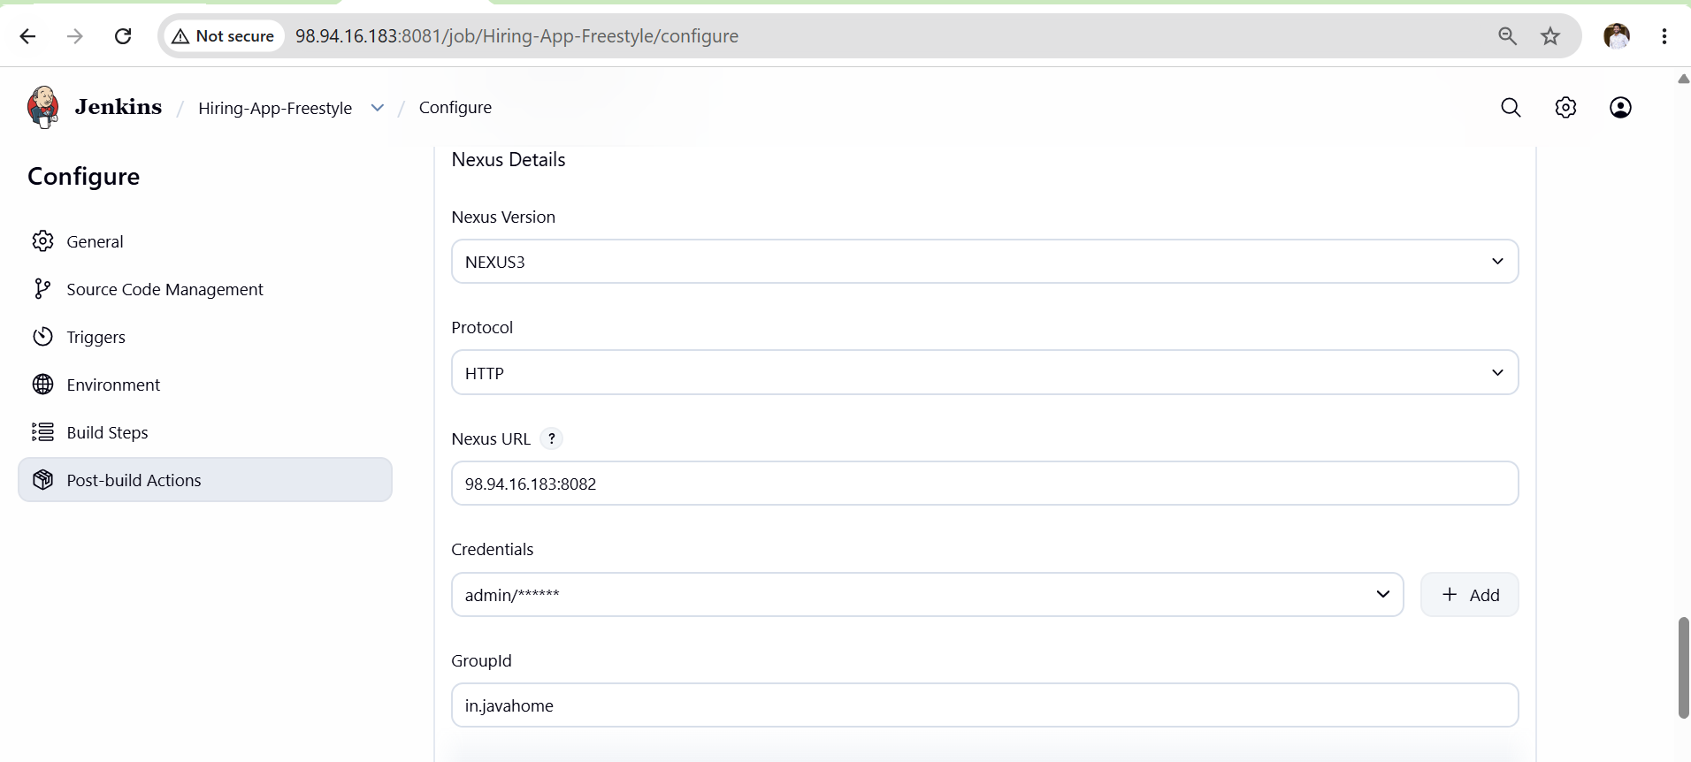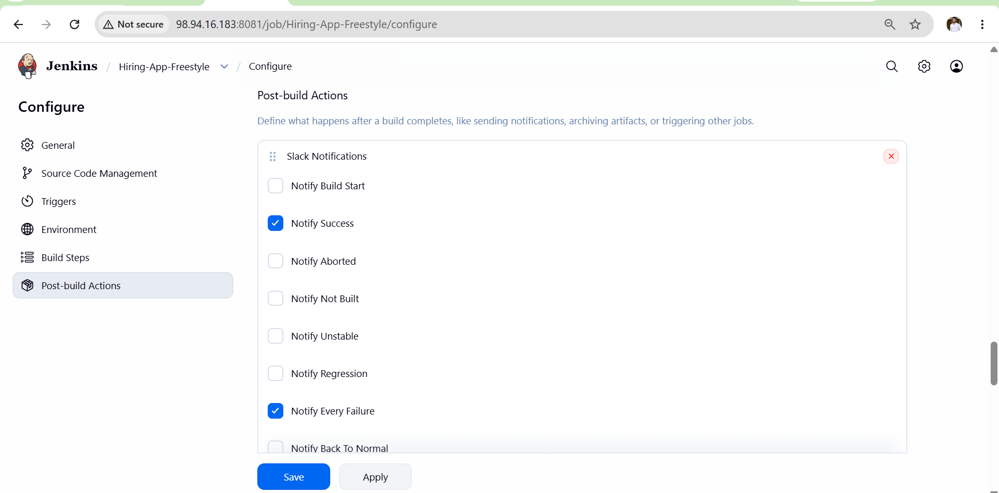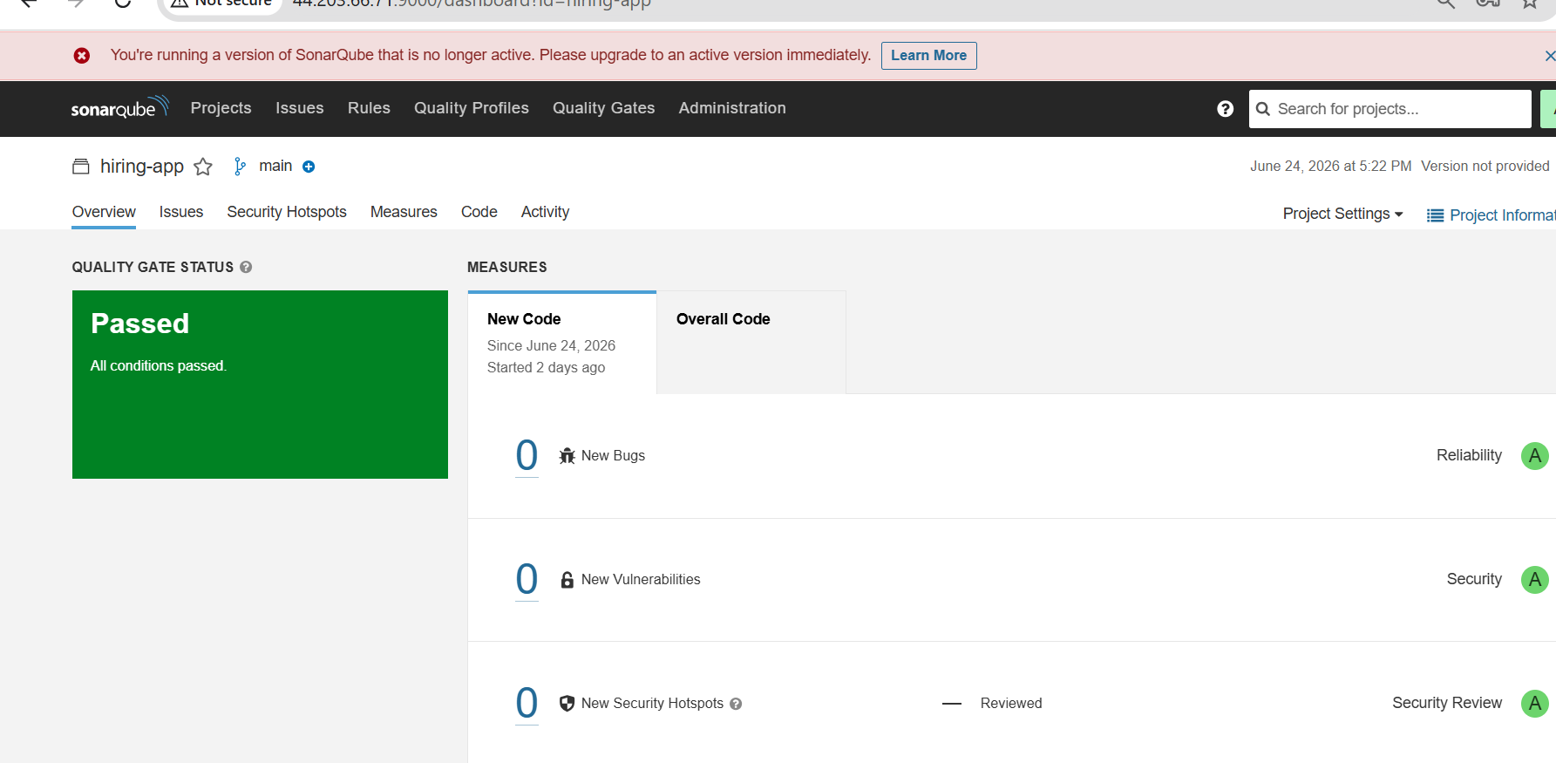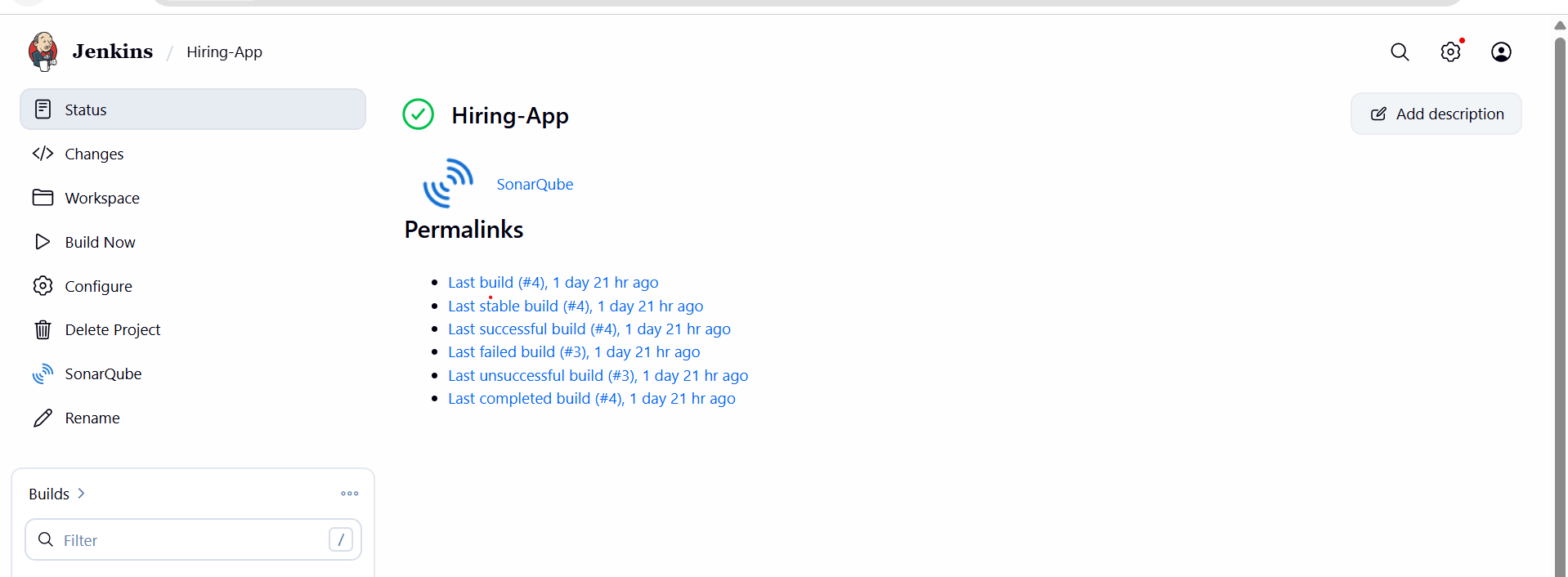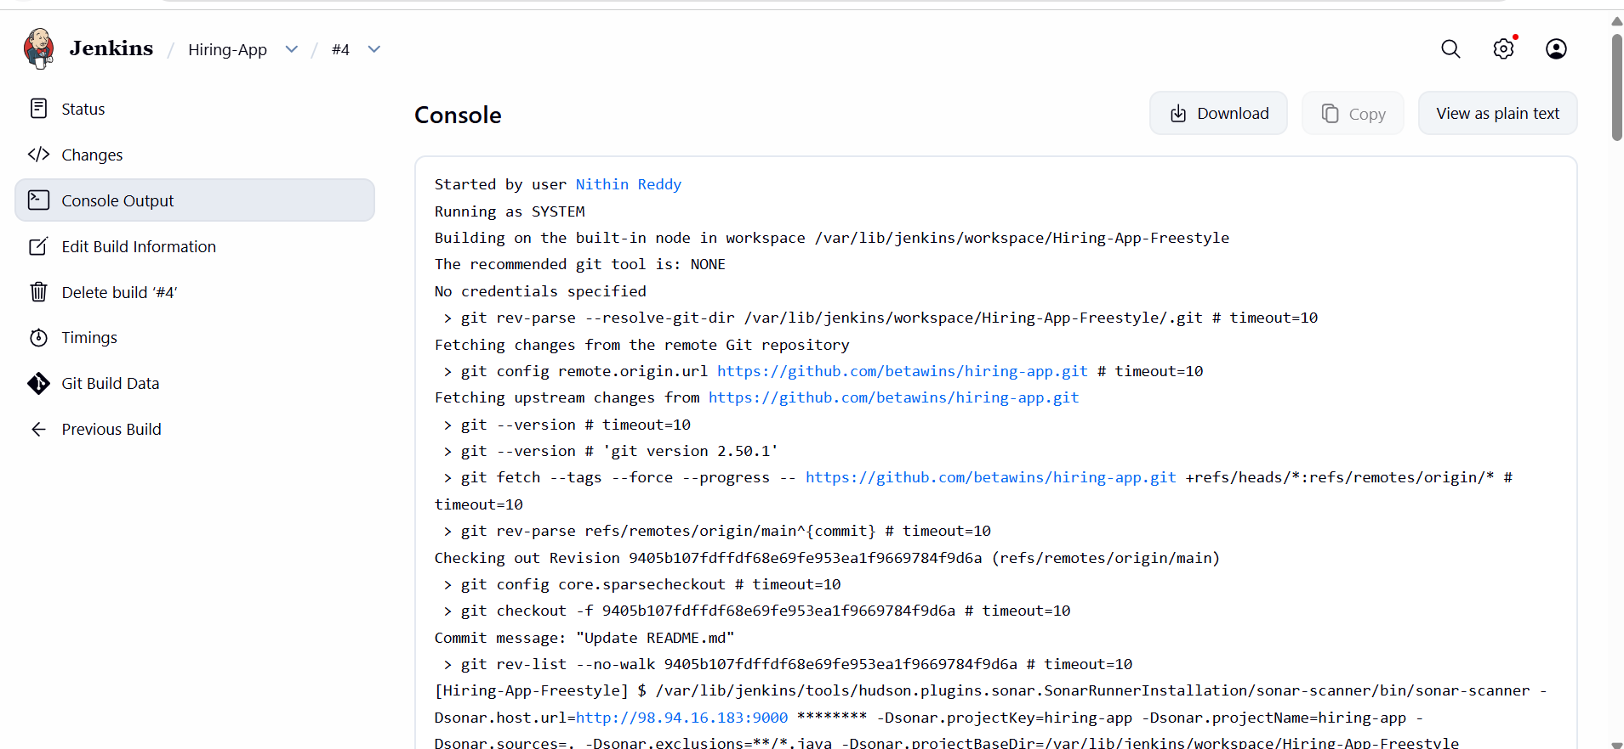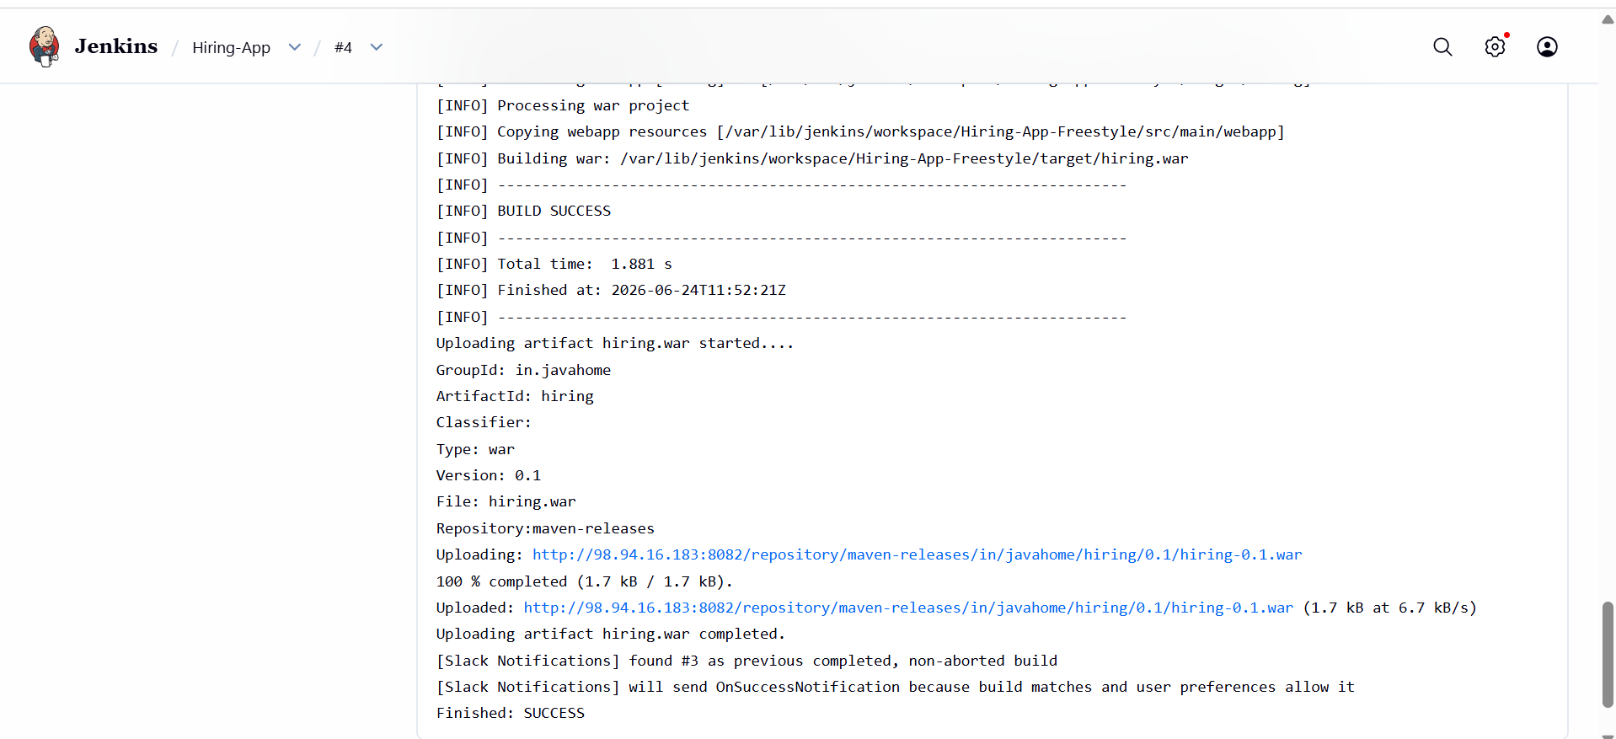

Outcome
- Successfully cloned the hiring-app repository from https://github.com/betawins/hiring-app.git
- Explored the repository structure and identified the application source code files
- Located the pom.xml file confirming it is a Maven-based Java web application
- Identified the WAR packaging configuration in pom.xml
- Understood the project structure: src/main/java for Java code, src/main/webapp for web files
- Repository is confirmed as the source code base for all upcoming pipeline challenges

Challenge 02 : Create one Declarative pipeline job
Objective
- Understand the structure and syntax of a Declarative Jenkins pipeline
- Create a Jenkins pipeline job using Declarative syntax for the hiring-app project
- Integrate SonarQube analysis, Maven build, Nexus upload, and Slack notification in Declarative style
Prerequisites
- Jenkins is installed and running
- Maven tool configured in Jenkins Global Tool Configuration with name mavan
- SonarQube server configured in Jenkins Configure System with name sonarqube
- SonarQube Scanner tool configured with name sonar-scanner
- Nexus Repository Manager running with maven-releases repository created
- Following credentials added in Jenkins Credentials:
  - sonar-token → Secret text (SonarQube token)
  - nexus → Username and Password (Nexus login)
  - slack → Secret text (Slack Webhook URL)
- Source code available at https://github.com/betawins/hiring-app.git

Steps
- Open Jenkins Dashboard → Click New Item
- Enter job name hiring-app-declarative → Select Pipeline → Click OK
- Scroll down to Pipeline section → Select Pipeline script
- Paste the Declarative pipeline code → Click Save
- Click Build Now and monitor the Stage View
- Verify all 5 stages complete: Pipeline Info, Git Clone, SonarQube Analysis, Maven Build, Nexus Upload
- Check Slack channel for SUCCESS notification
- Check Nexus for uploaded WAR file

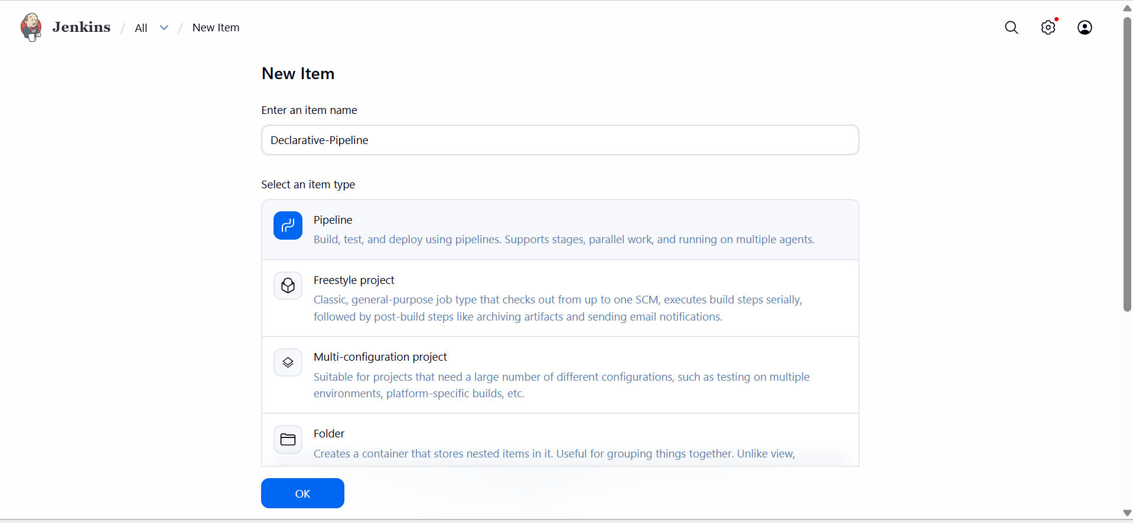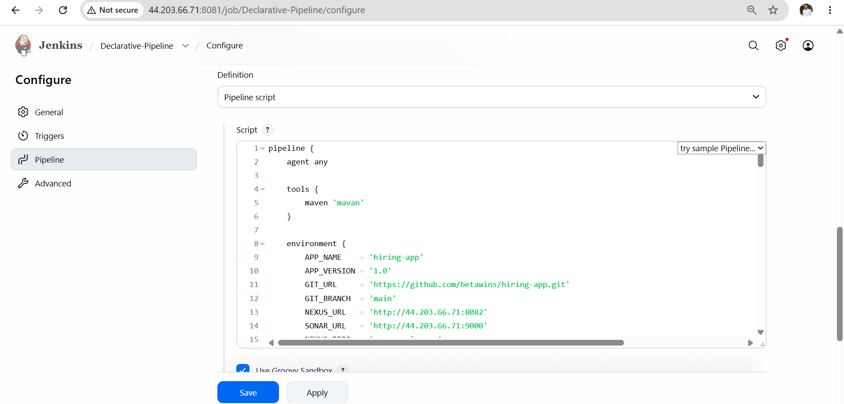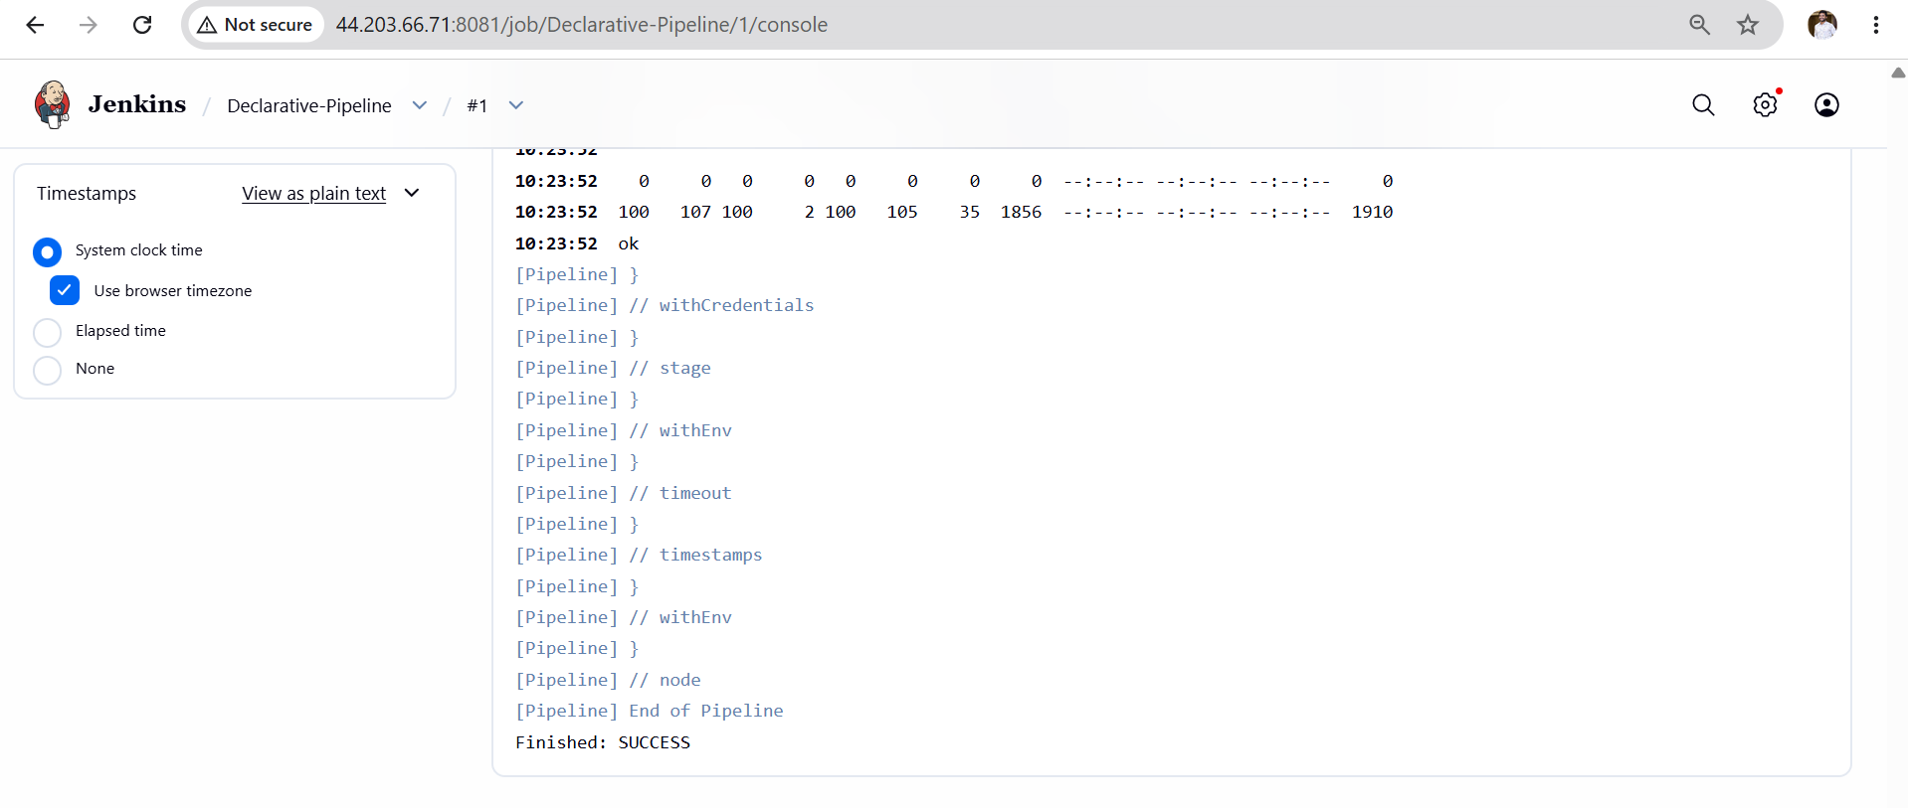

Validation Points
- Jenkins build shows success for hiring-app-declarative job
- All 5 stages visible and green in Stage View
- SonarQube dashboard shows project hiring-app-declarative with analysis report
- Nexus maven-releases repository contains uploaded WAR file
- Slack channel received SUCCESS message with correct build number and job name
- Workspace cleaned after build via cleanWs() in post { always } block
- Pipeline code uses pipeline {} block — confirming Declarative syntax
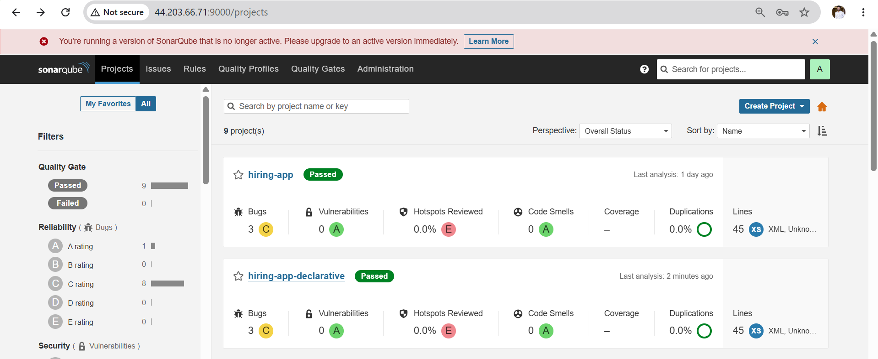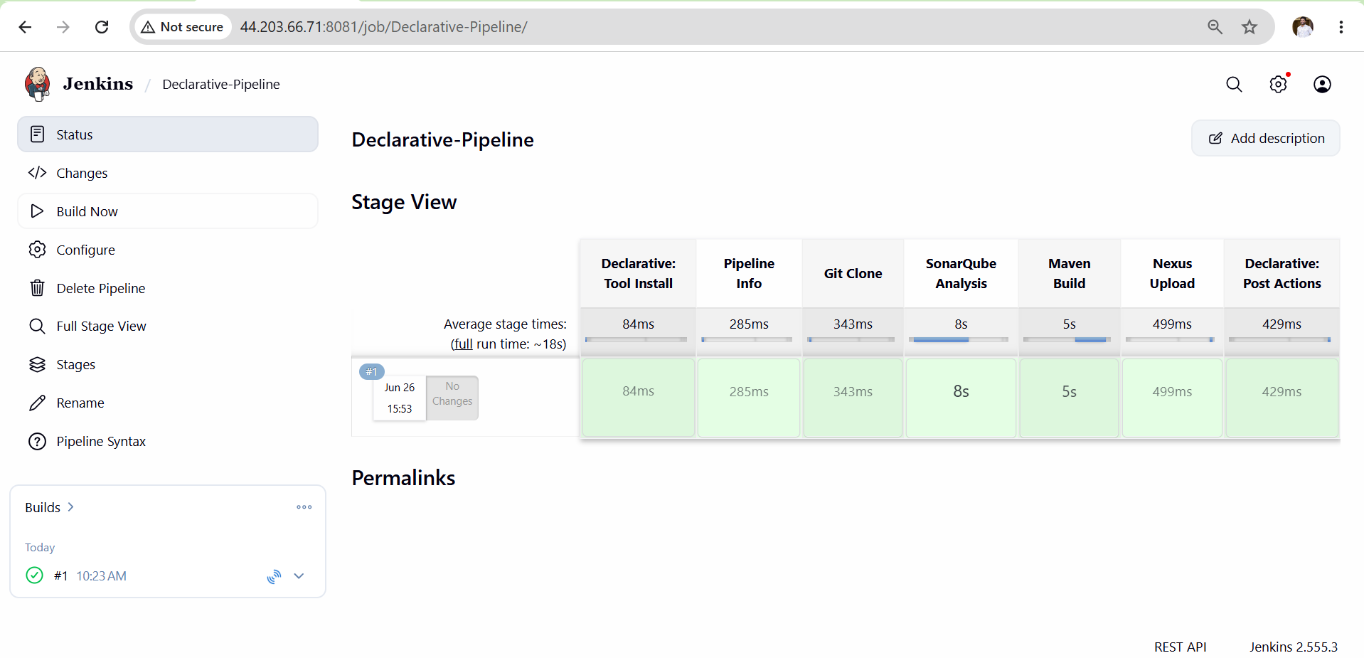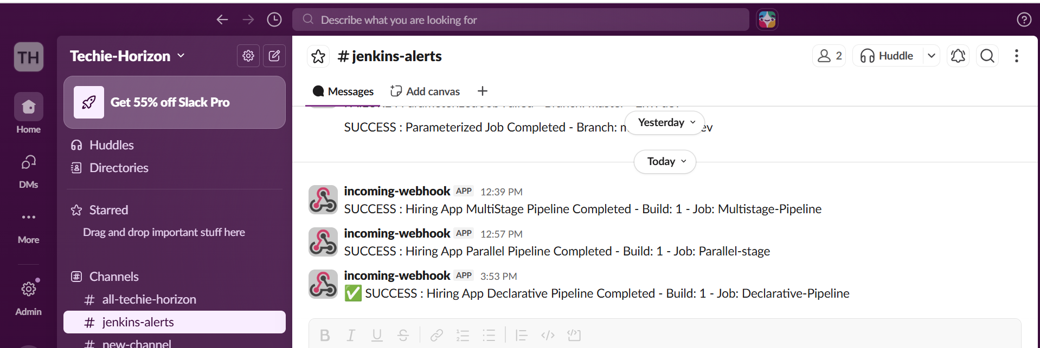

Outcome
- Successfully created a Declarative pipeline job in Jenkins
- Pipeline executed all stages in order: Pipeline Info → Git Clone → SonarQube Analysis → Maven Build → Nexus Upload
- WAR file built by Maven was uploaded to Nexus maven-releases repository
- Slack channel received SUCCESS or FAILURE notification after build
- Understood Declarative pipeline structure using pipeline {}, stages {}, post {} blocks

Challenge 03 : Create one Scripted pipeline job
Objective
- Understand the structure and syntax of a Scripted Jenkins pipeline
- Create a Jenkins pipeline job using Scripted Groovy syntax for the hiring-app project
- Integrate SonarQube analysis, Maven build, Nexus upload, and Slack notification in Scripted style
- Understand the difference between Declarative and Scripted pipeline error handling
Prerequisites
- Jenkins is installed and running
- Maven tool configured in Jenkins Global Tool Configuration with name mavan
- SonarQube server configured in Jenkins Configure System with name sonarqube
- SonarQube Scanner tool configured with name sonar-scanner
- Nexus Repository Manager running with maven-releases repository created
- Following credentials added in Jenkins Credentials:
  - sonar-token → Secret text (SonarQube token)
  - nexus → Username and Password (Nexus login)
  - slack → Secret text (Slack Webhook URL)
- Source code available at https://github.com/betawins/hiring-app.git
- Challenge 2 Declarative pipeline completed successfully

Steps
- Open Jenkins Dashboard → Click New Item
- Enter job name hiring-app-scripted → Select Pipeline → Click OK
- Scroll down to Pipeline section → Select Pipeline script
- Paste the Scripted pipeline code starting from node { → Click Save
- Click Build Now and monitor the Stage View
- Verify all 5 stages complete: Pipeline Info, Git Clone, SonarQube Analysis, Maven Build, Nexus Upload
- Check Slack channel for SUCCESS notification
- Check Nexus for uploaded WAR file

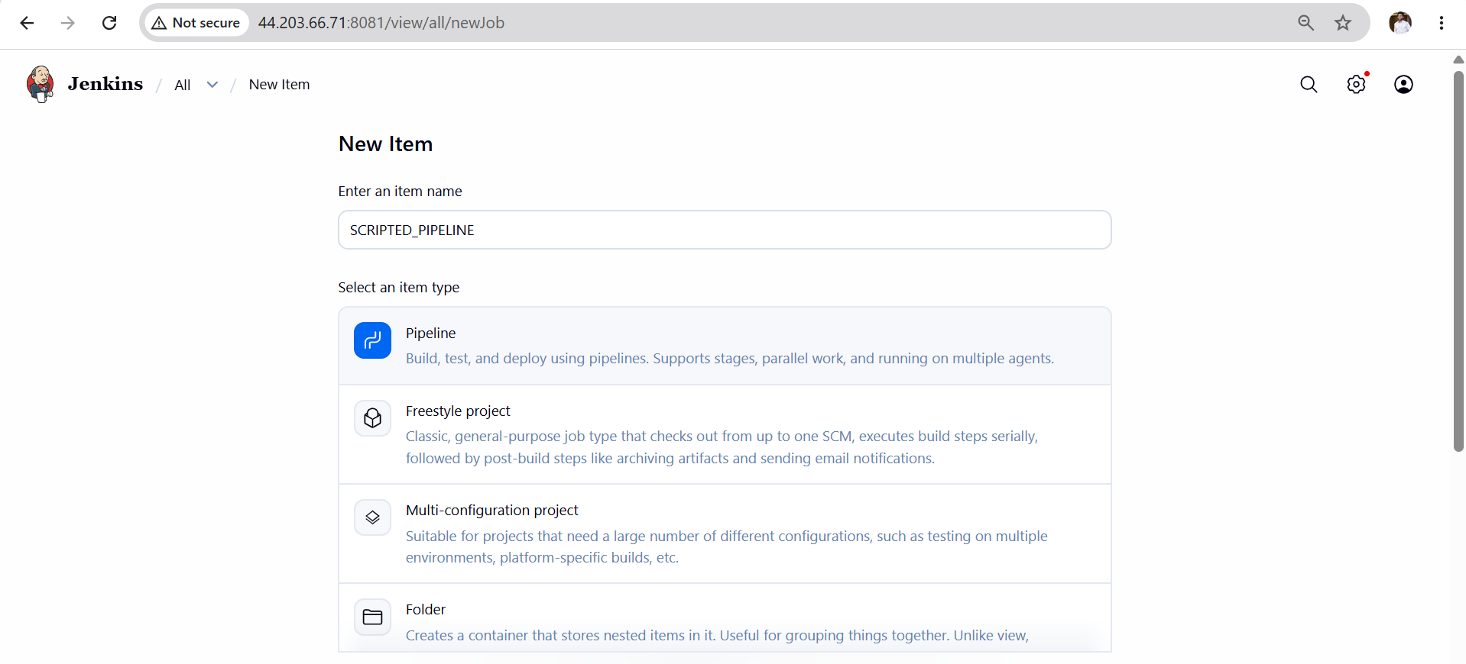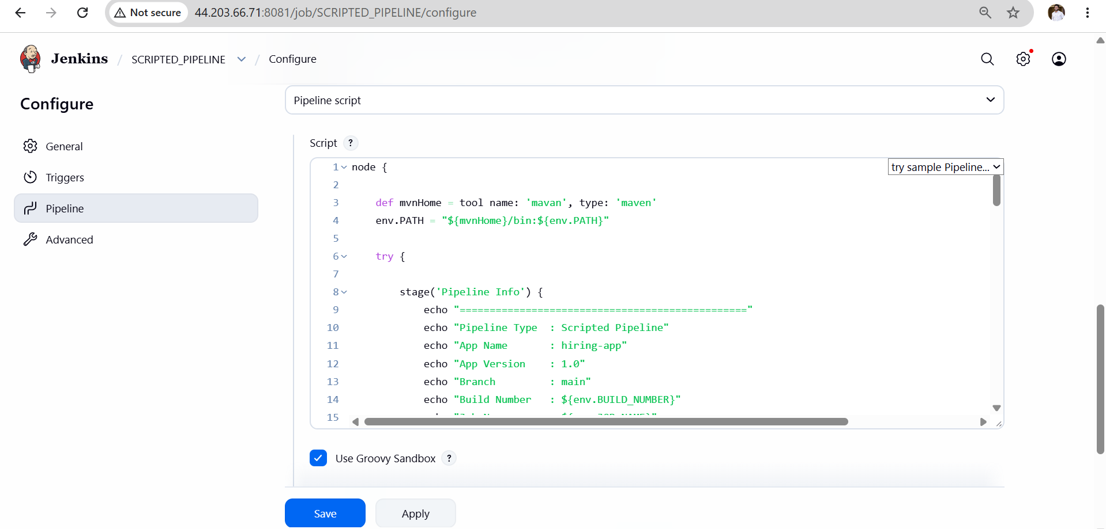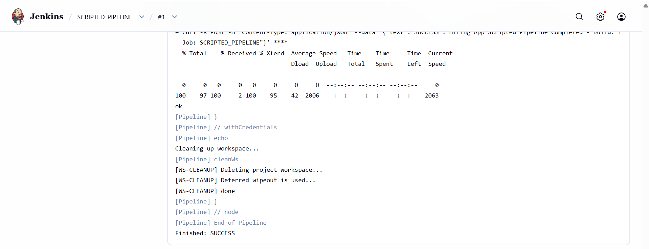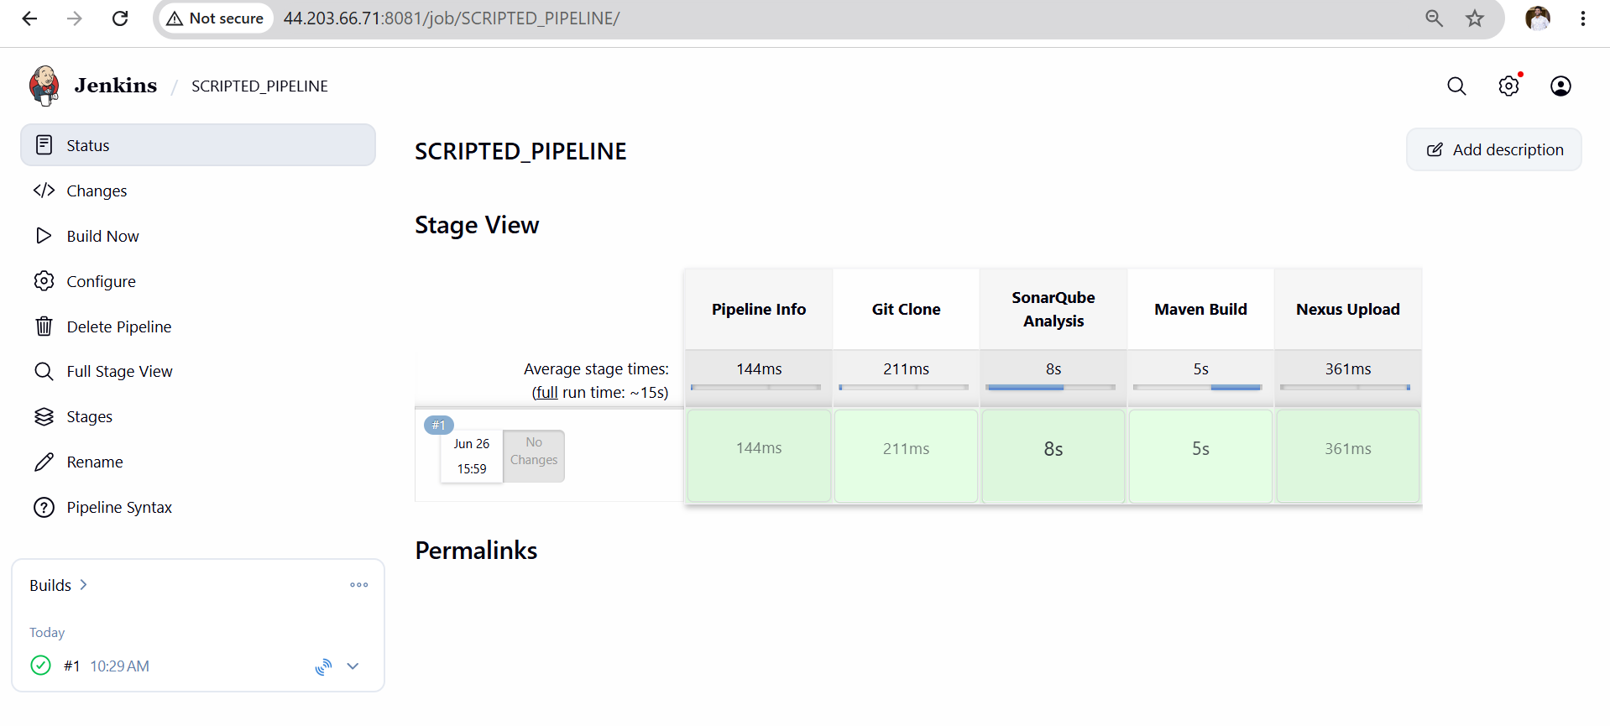
Validation Points
- Jenkins build shows success for hiring-app-scripted job
- All 5 stages visible and green in Stage View
- SonarQube dashboard shows project hiring-app-scripted with analysis report
- Nexus maven-releases repository contains uploaded WAR file
- Slack channel received SUCCESS message with correct build number and job name
- Workspace cleaned after build via cleanWs() in finally block
- Pipeline code uses node {} block — confirming Scripted syntax
- Error handling done via try/catch/finally instead of post {} block
- currentBuild.result manually set to SUCCESS or FAILURE confirming Scripted style
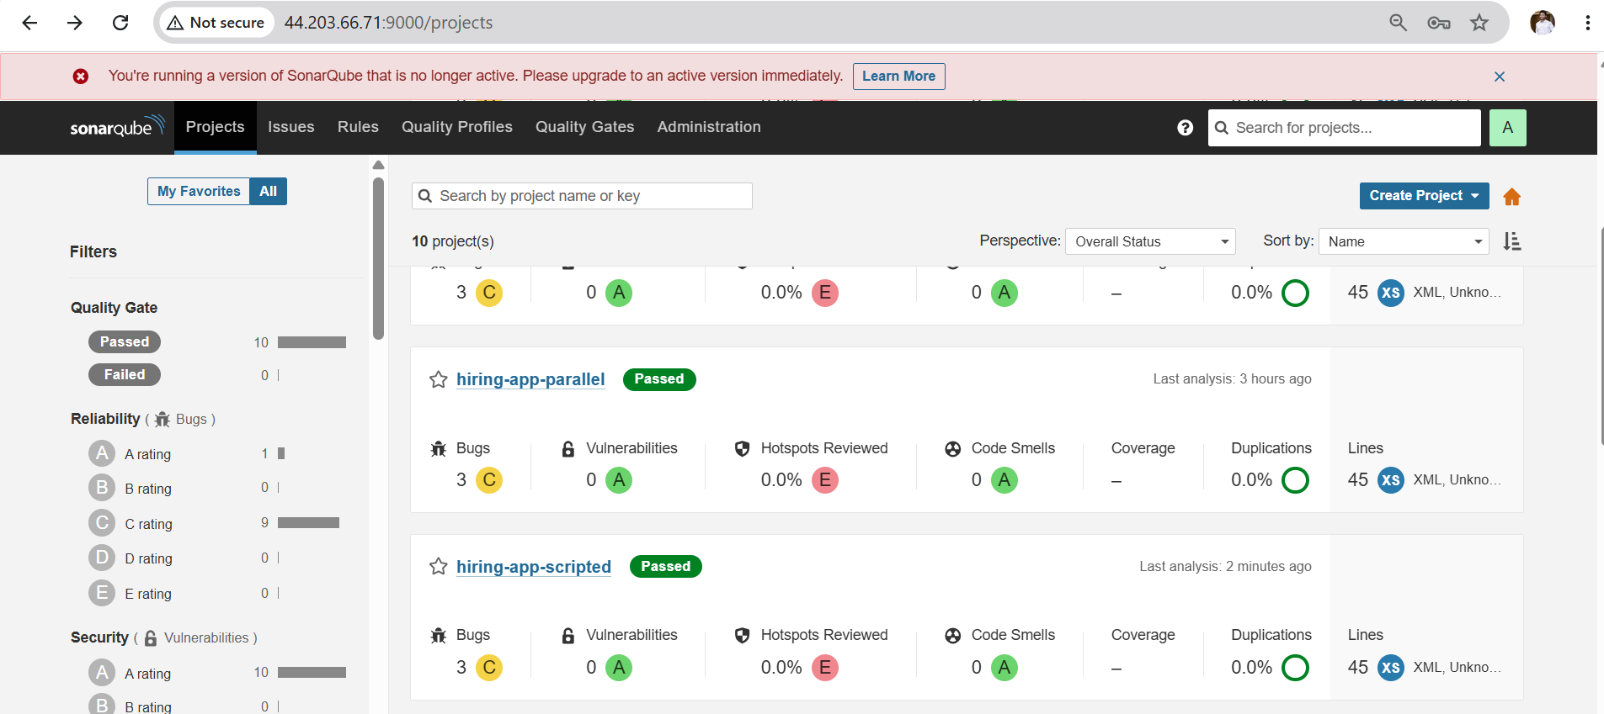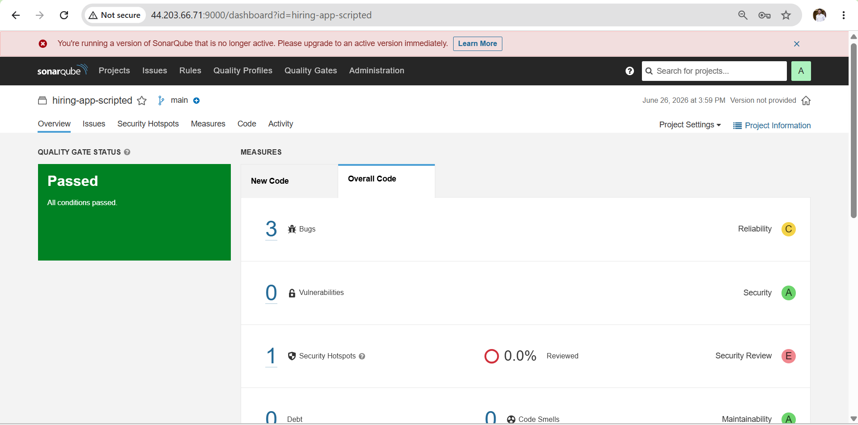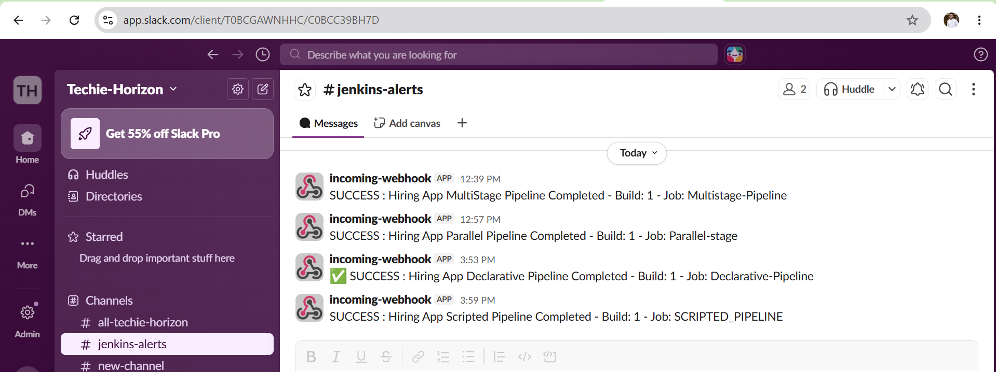

Outcome
- Successfully created a Scripted pipeline job in Jenkins
- Pipeline executed all stages in order: Pipeline Info → Git Clone → SonarQube Analysis → Maven Build → Nexus Upload
- WAR file built by Maven was uploaded to Nexus maven-releases repository
- Slack channel received SUCCESS or FAILURE notification after build
- Understood Scripted pipeline structure using node {}, stage(), try/catch/finally blocks

Challenge 4: Multi Stage Pipeline Job

Objective
Create a Jenkins Multi Stage Pipeline for the hiring-app that runs multiple stages in a structured sequence with proper error handling, notifications and deployment.
Prerequisites
Server Requirements
- Jenkins running at http://44.203.66.71:8080
- SonarQube running at http://44.203.66.71:9000
- Nexus running at http://44.203.66.71:8082
Jenkins Tools Configured
- Maven installed in Jenkins Tools with name mavan
- SonarQube Scanner configured with name sonar-scanner
Jenkins Credentials Required
- sonar-token — SonarQube authentication token
- nexus — Nexus username and password
- slack — Slack webhook URL
Plugins Required
- Pipeline
- Git
- SonarQube Scanner
- Workspace Cleanup

Steps
- SSH into server and verify all tools are running
- Verify Jenkins credentials exist for sonar-token, nexus and slack
- Go to Jenkins → New Item → Enter name Hiring-App-MultiStage-Pipeline
- Select Pipeline → Click OK
- Scroll to Pipeline section → Select Pipeline script
- Paste the complete pipeline script
- Click Save
- Click Build Now
- Watch Stage View — verify all stages go green
- Check SonarQube dashboard for analysis report
- Check Nexus repository for uploaded WAR file
- Check Slack channel for success notification
Validation Points
Jenkins
- Job Hiring-App-MultiStage-Pipeline created successfully
- All 5 stages visible in Stage View
- All stages show green on successful run
- Console output shows BUILD SUCCESS
- Console output shows Running on Jenkins node
Git Clone
- Console shows commit message from main branch
- Workspace contains hiring-app source code
SonarQube
- Analysis report visible at:
http://44.203.66.71:9000/dashboard?id=hiring-app-multistage
Maven Build
- Console shows BUILD SUCCESS
- WAR file created in target folder
- Console shows WAR file listed after build

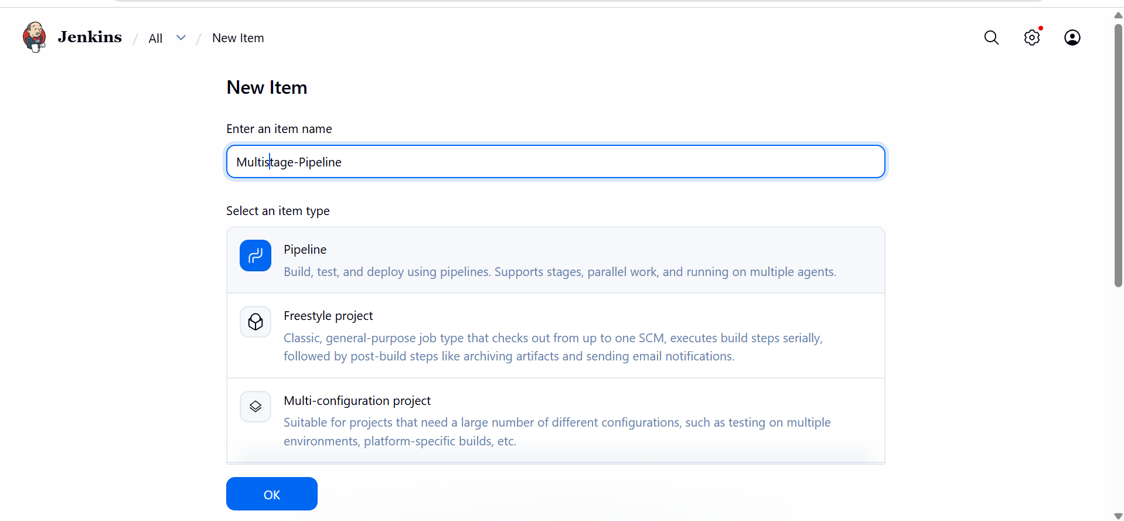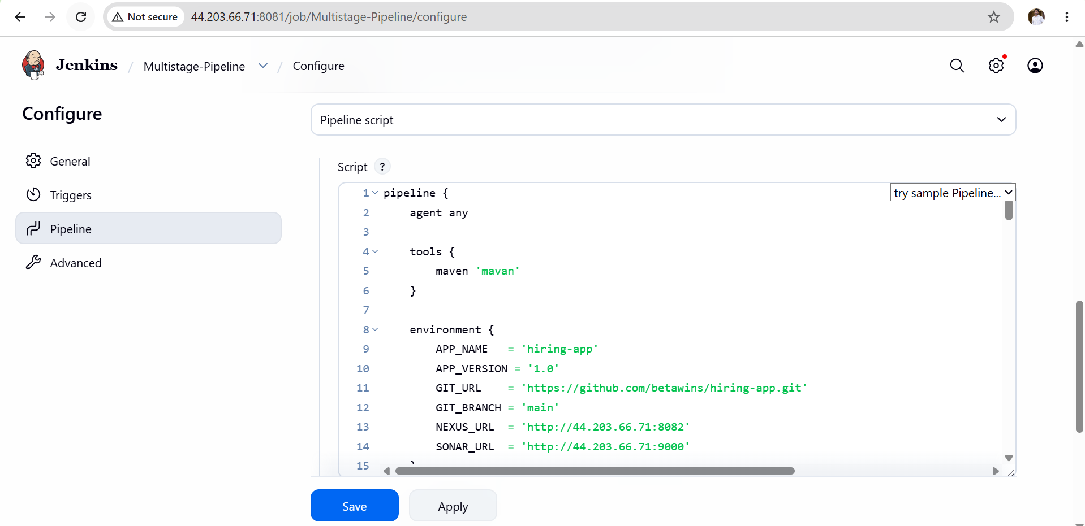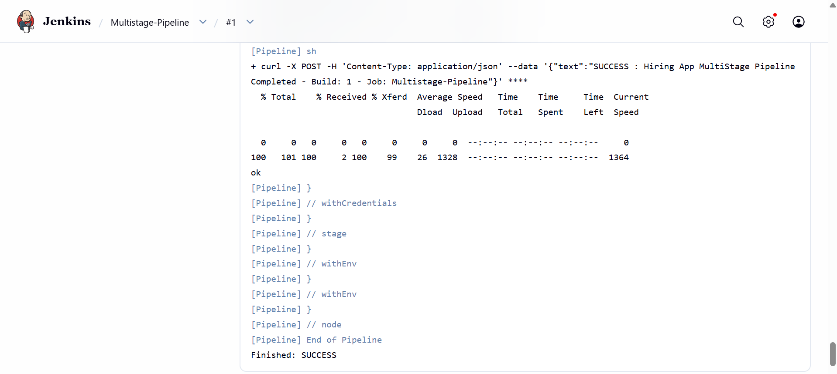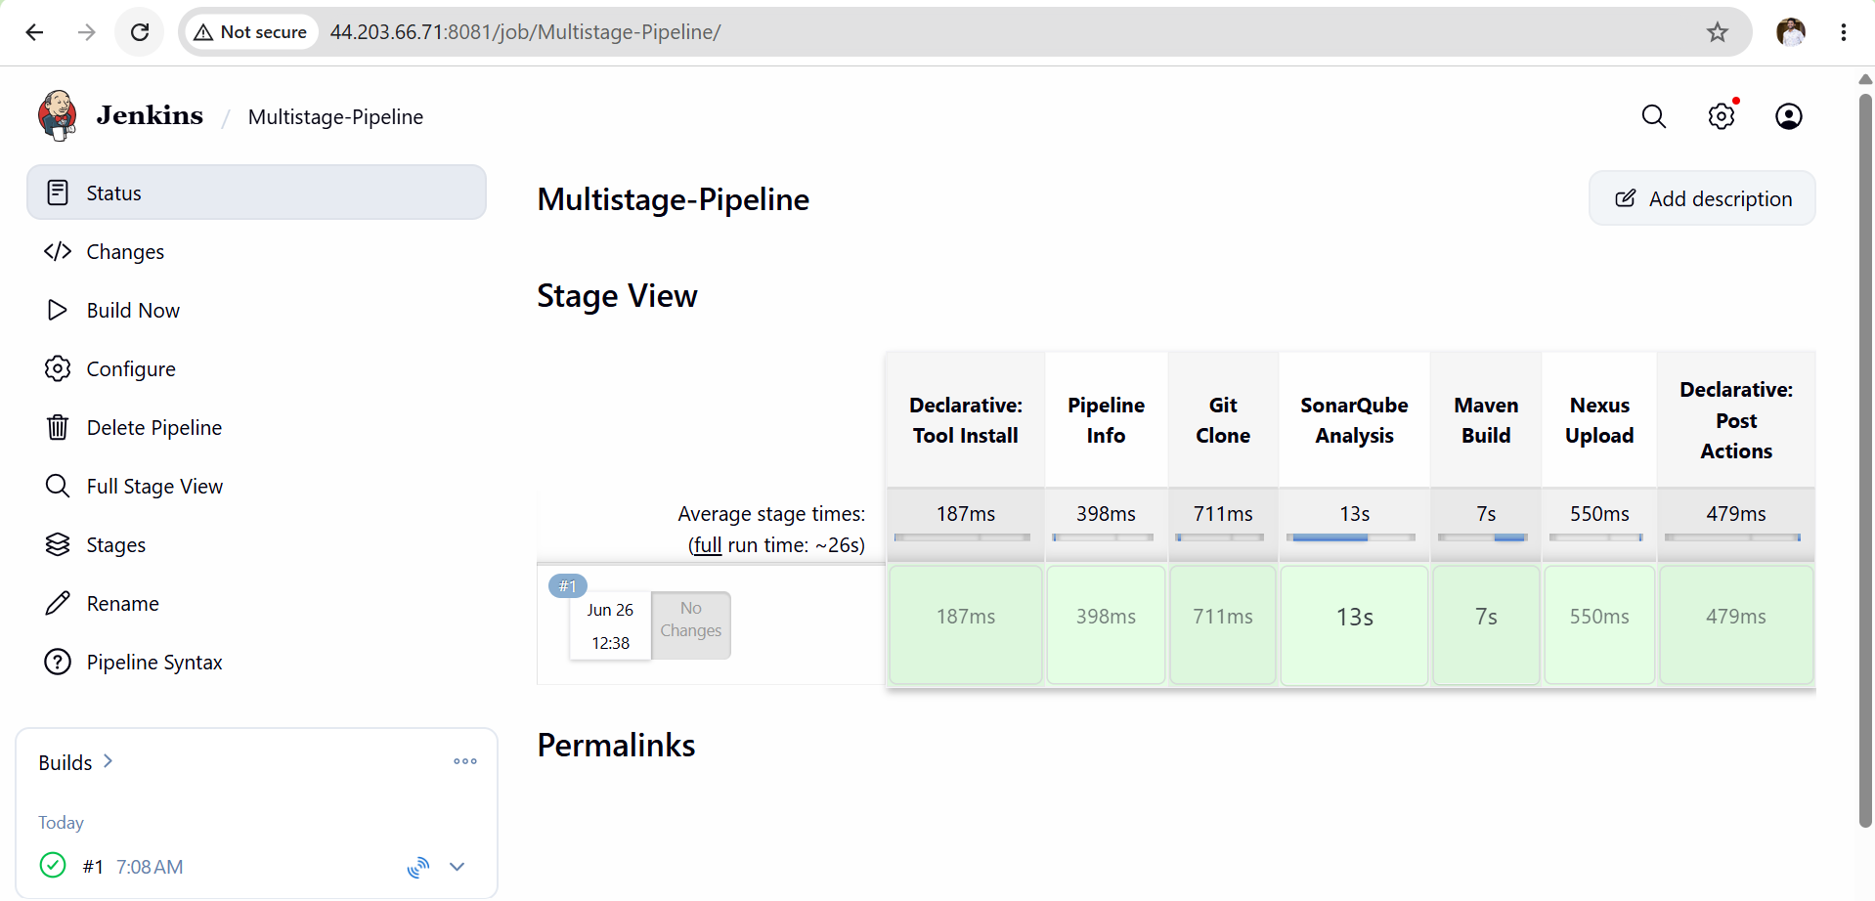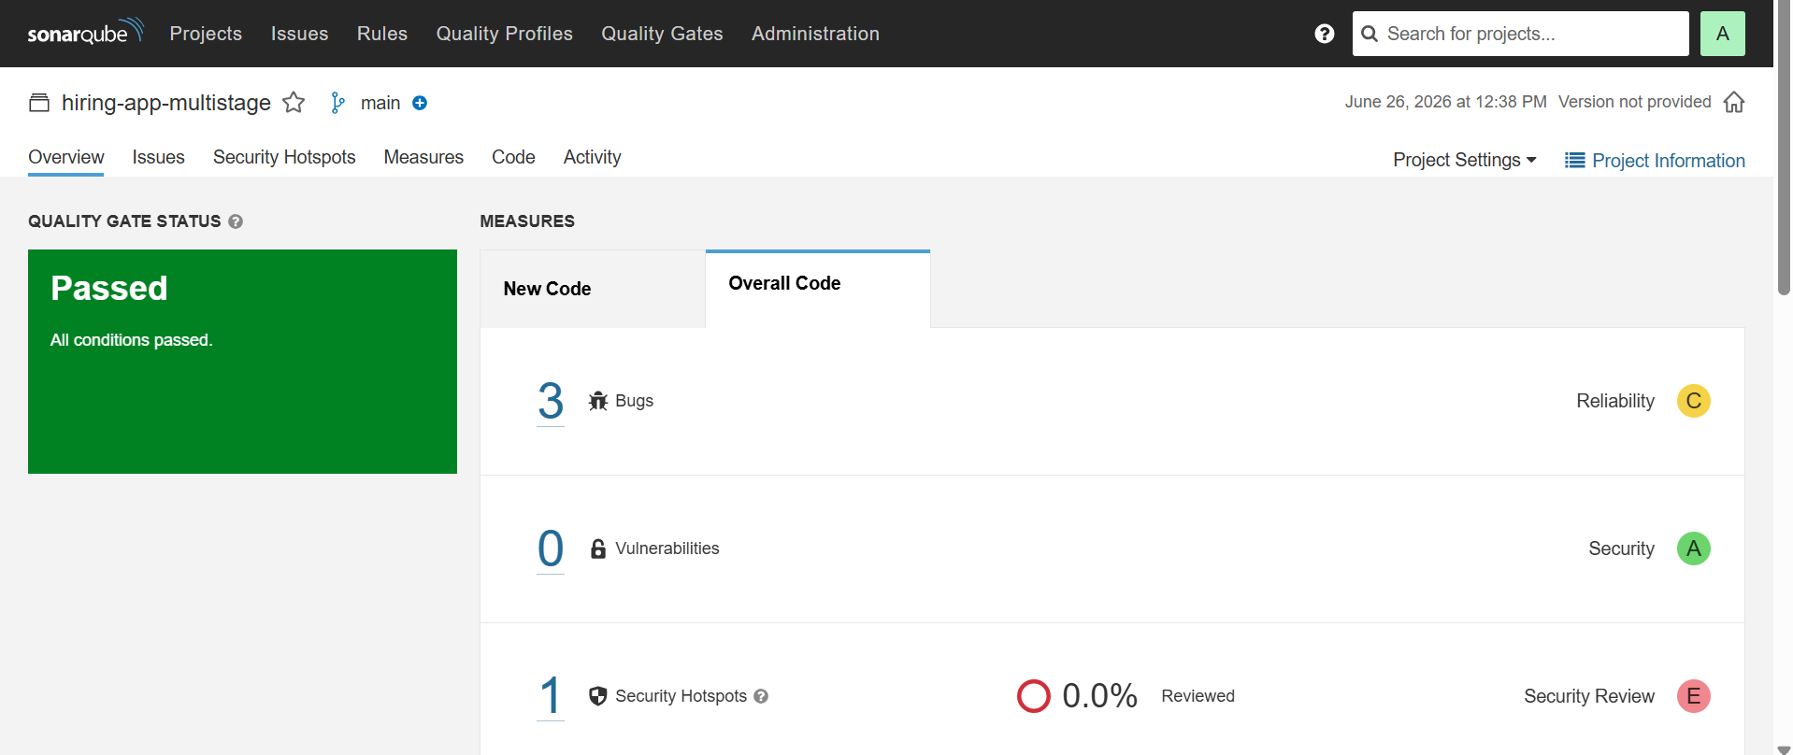
Nexus Upload
- WAR file visible in Nexus at:
http://44.203.66.71:8082
Browse → maven-releases → com/betawins/hiring-app/1.0/
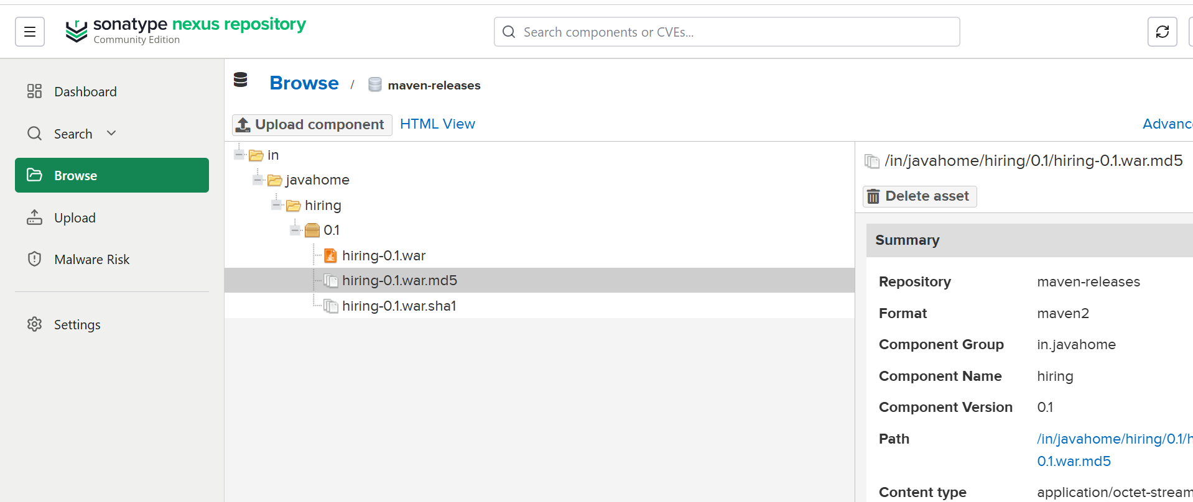
Slack
- Success message received in Slack channel:
SUCCESS : Hiring App MultiStage Pipeline Completed
Build: #1 - Job: Hiring-App-MultiStage-Pipeline
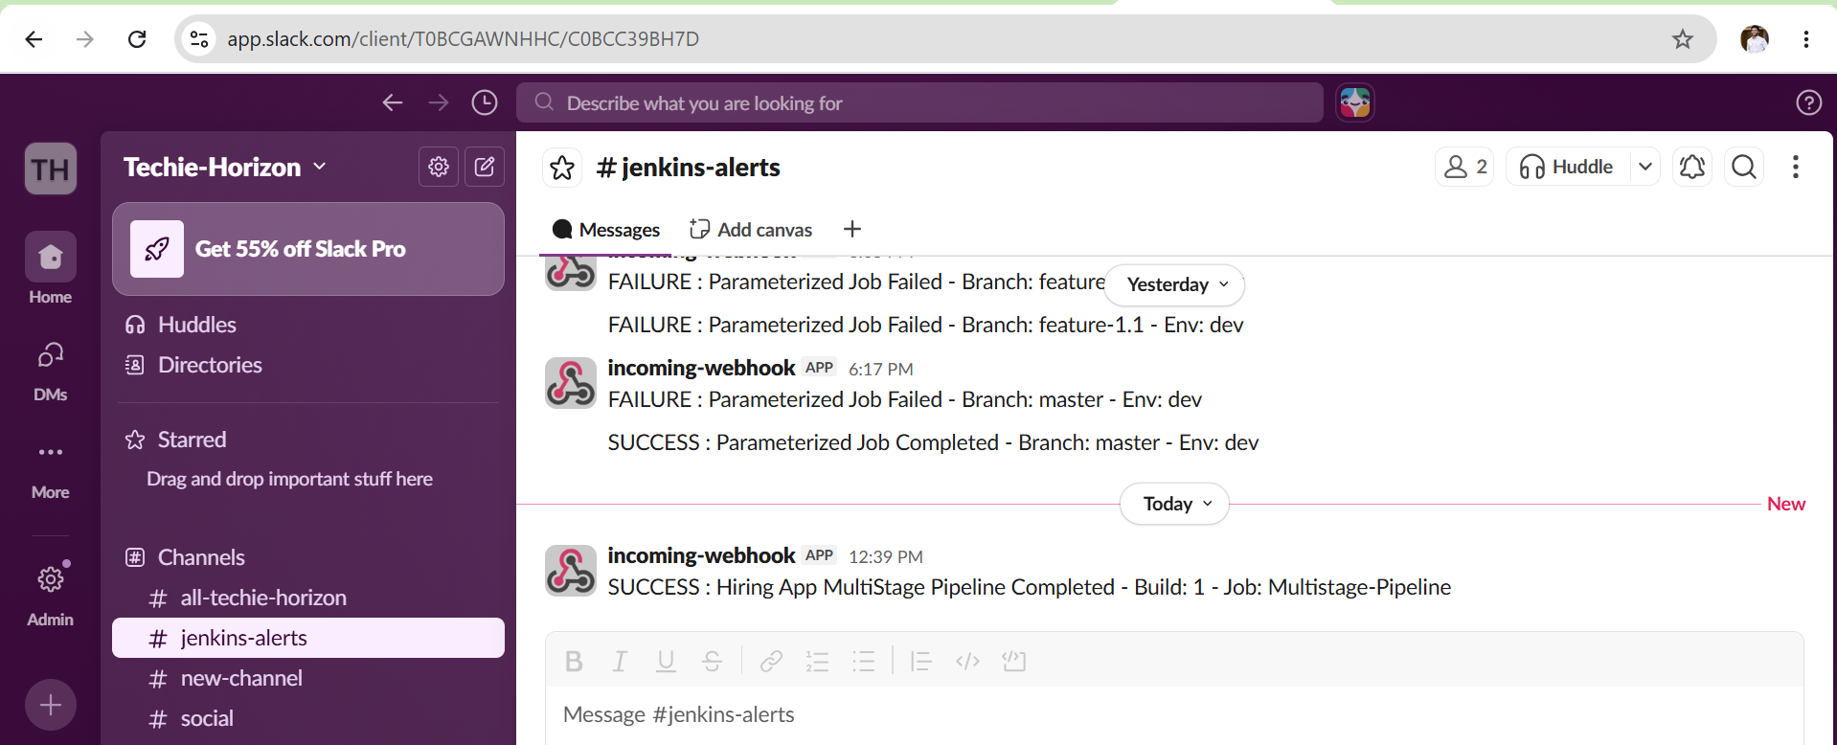
Outcome
- A Jenkins Multi Stage Pipeline job created and running successfully
- All 5 stages visible and green in Jenkins Stage View
- Code cloned from main branch of hiring-app repository
- SonarQube analysis report generated and visible on dashboard
- WAR artifact built by Maven and uploaded to Nexus repository
Challenge 5: Parallel Stage Pipeline Job — Hiring App
Objective
Create a Jenkins Parallel Stage Pipeline for the hiring-app where multiple stages run simultaneously at the same time, reducing overall build time.
Prerequisites
Server Requirements
- Jenkins running at http://44.203.66.71:8080
- SonarQube running at http://44.203.66.71:9000
- Nexus running at http://44.203.66.71:8082
Jenkins Tools Configured
- Maven installed in Jenkins Tools with name mavan
- SonarQube Scanner configured with name sonar-scanner
Jenkins Credentials Required
- sonar-token — SonarQube authentication token
- nexus — Nexus username and password
- slack — Slack webhook URL
Plugins Required
- Pipeline
- Git
- SonarQube Scanner
- Workspace Cleanup

Steps
- SSH into server and verify all tools are running
- Verify Jenkins credentials exist for sonar-token, nexus and slack
- Go to Jenkins → New Item → Enter name Hiring-App-MultiStage-Pipeline
- Select Pipeline → Click OK
- Scroll to Pipeline section → Select Pipeline script
- Paste the complete pipeline script
- Click Save
- Click Build Now
- Watch Stage View — verify all stages go green
- Check SonarQube dashboard for analysis report
- Check Nexus repository for uploaded WAR file
- Check Slack channel for success notification

Validation Points
Jenkins
- Job Hiring-App-MultiStage-Pipeline created successfully
- All 5 stages visible in Stage View
- All stages show green on successful run
- Console output shows BUILD SUCCESS
- Console output shows Running on Jenkins node

Git Clone
- Console shows commit message from main branch
- Workspace contains hiring-app source code
Maven Build
- Console shows BUILD SUCCESS
- WAR file created in target folder
- Console shows WAR file listed after build
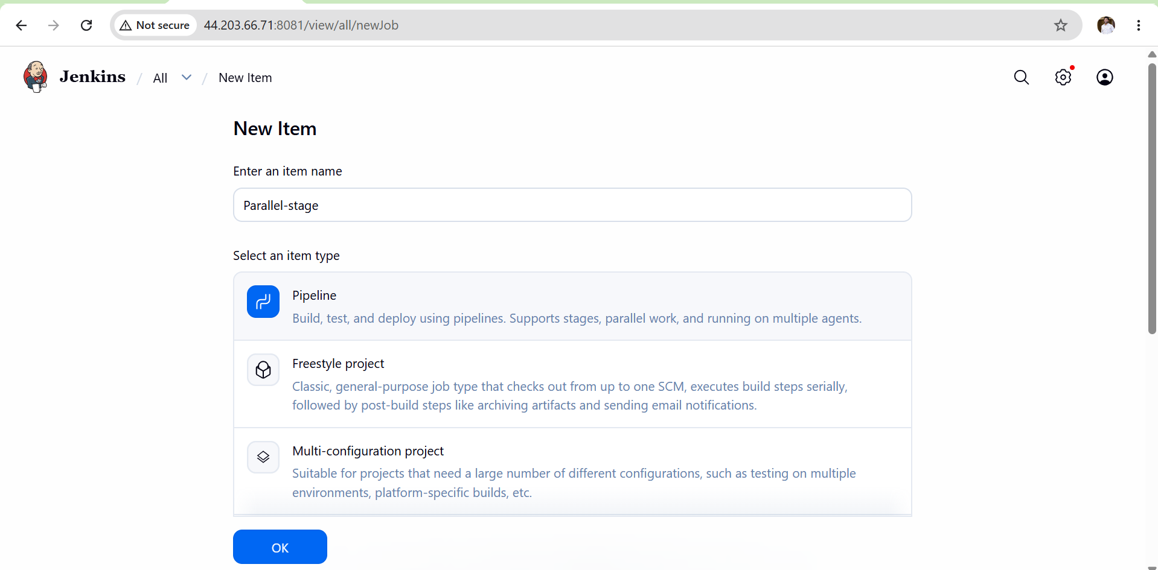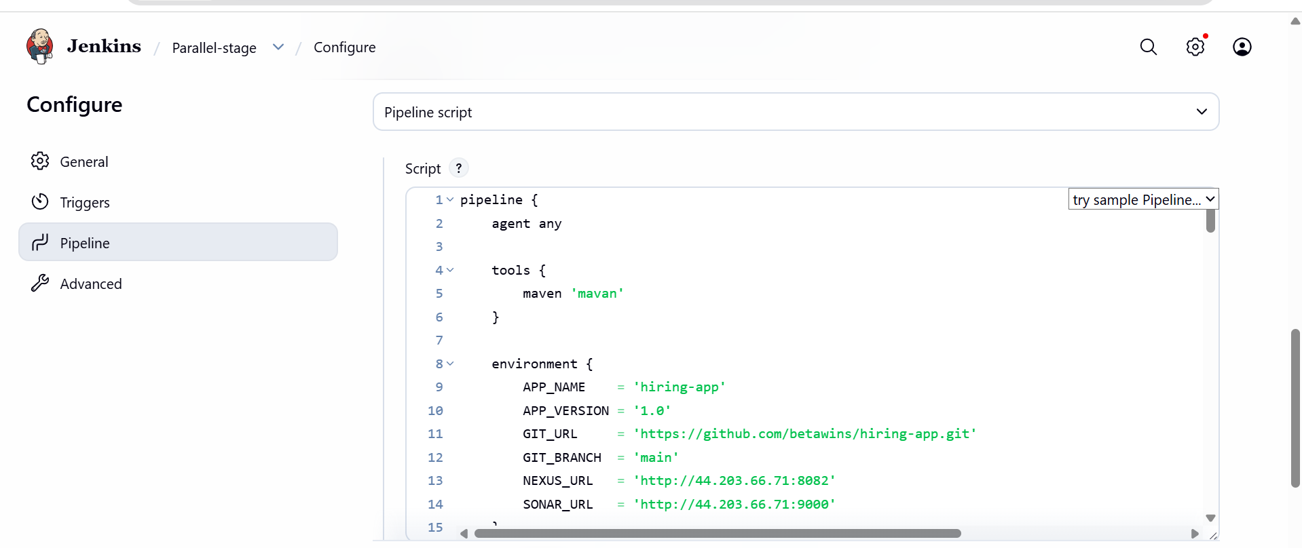

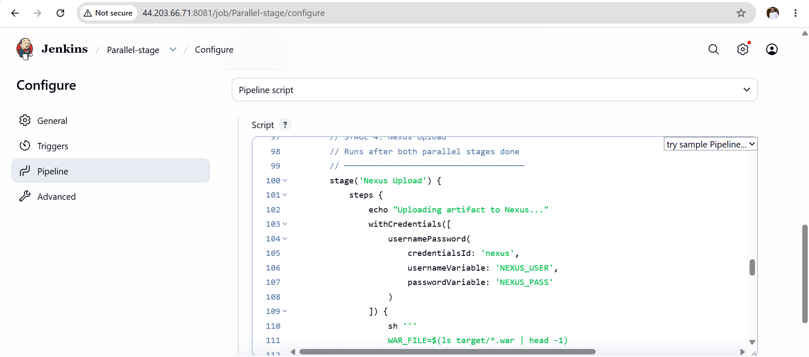
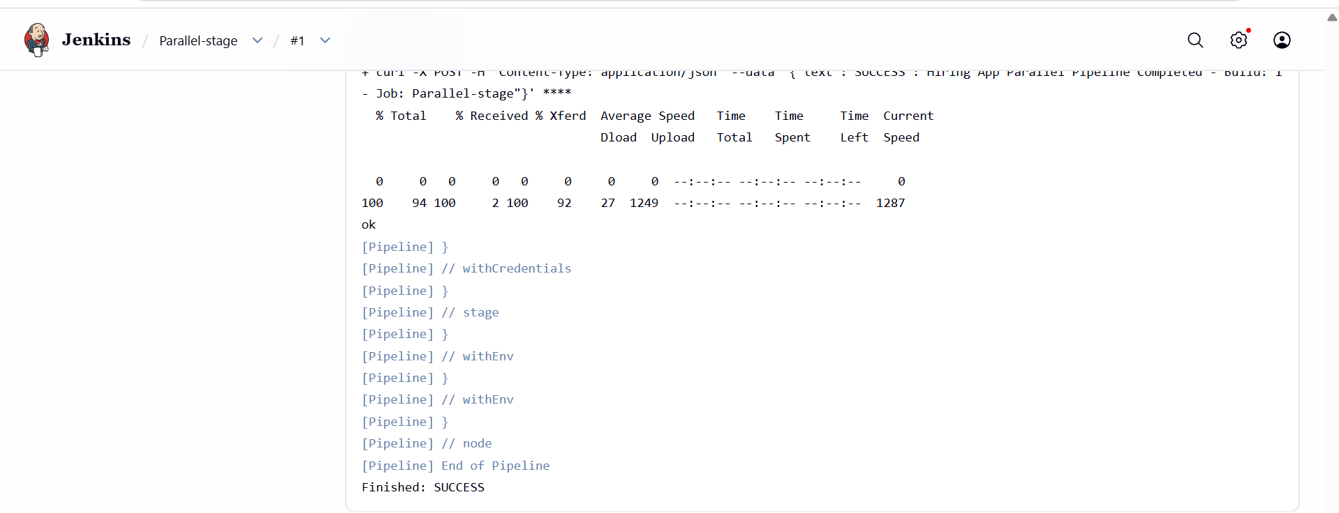
SonarQube
- Analysis report visible at:
http://44.203.66.71:9000/dashboard?id=hiring-app-multistage
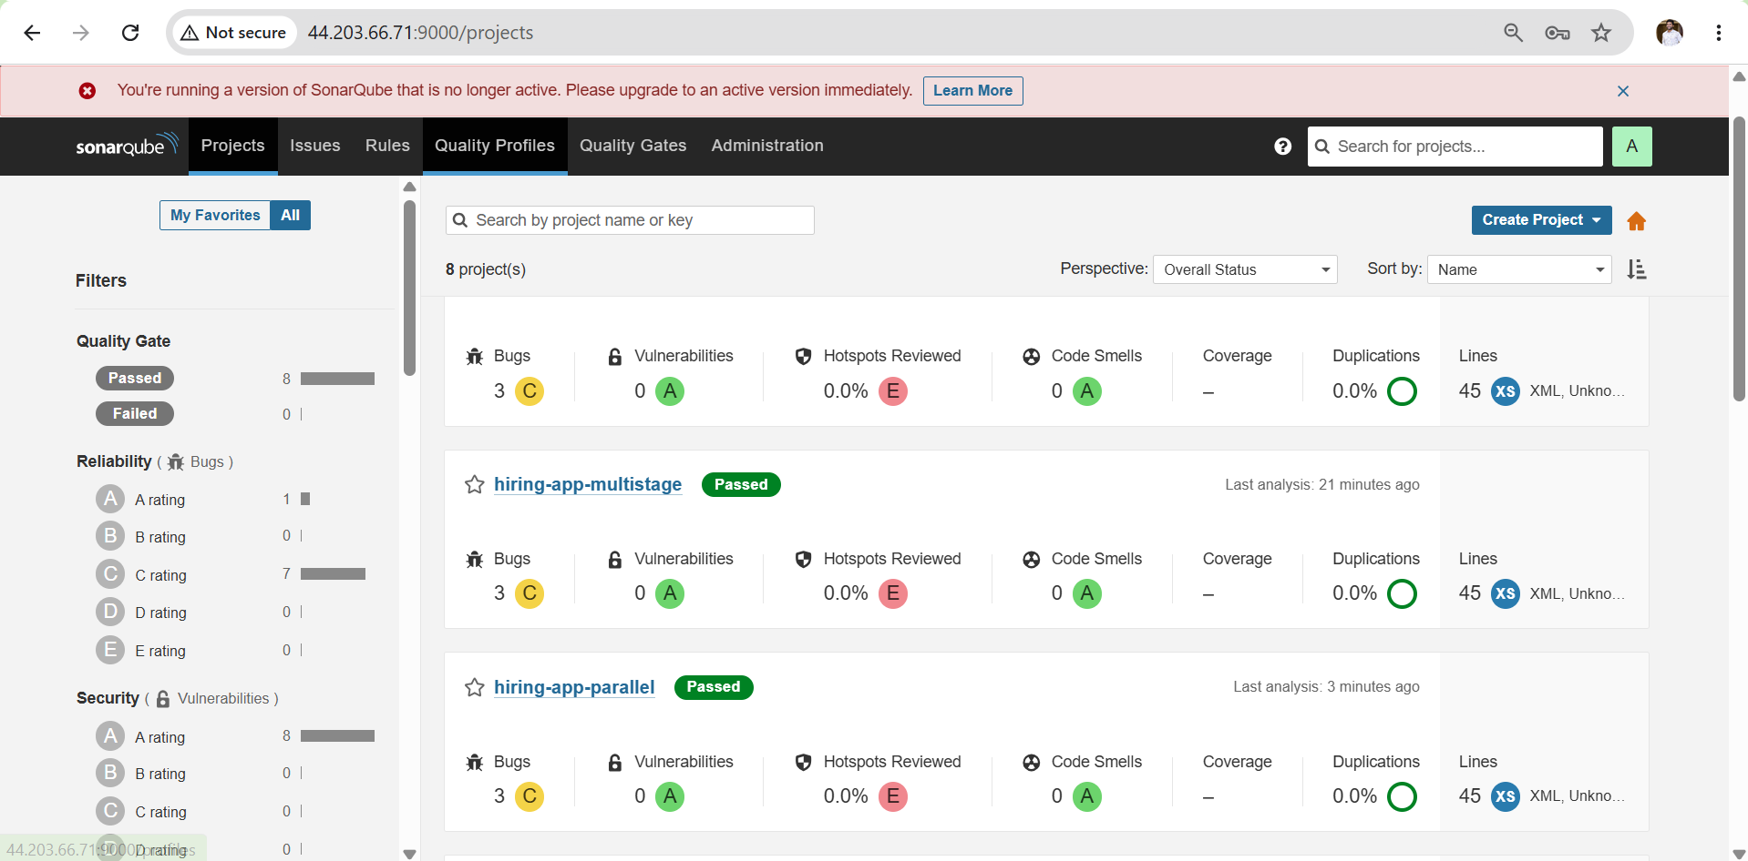
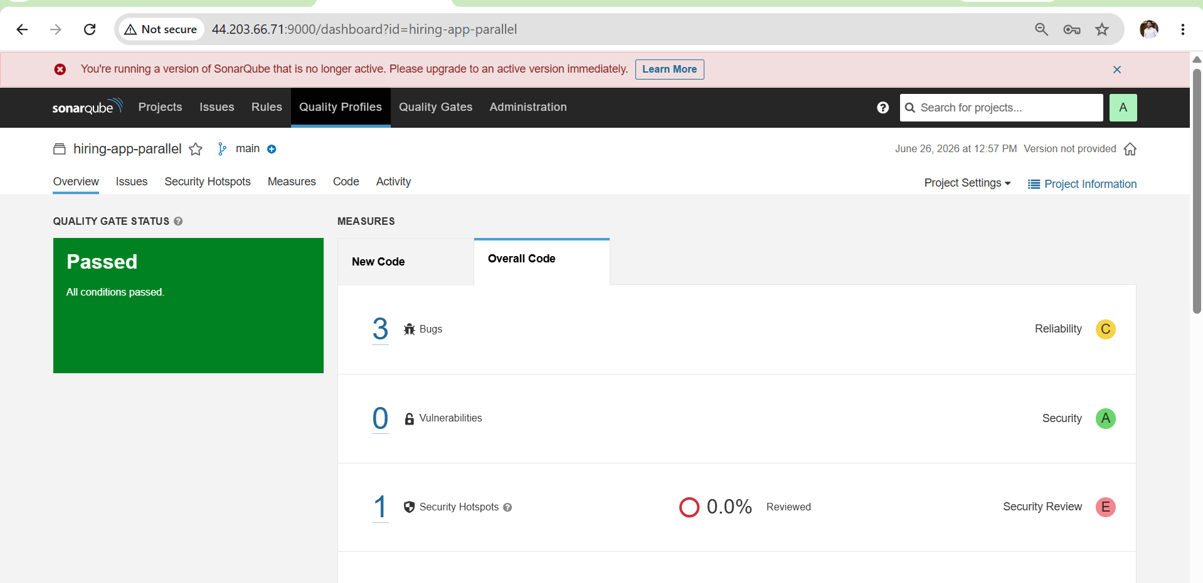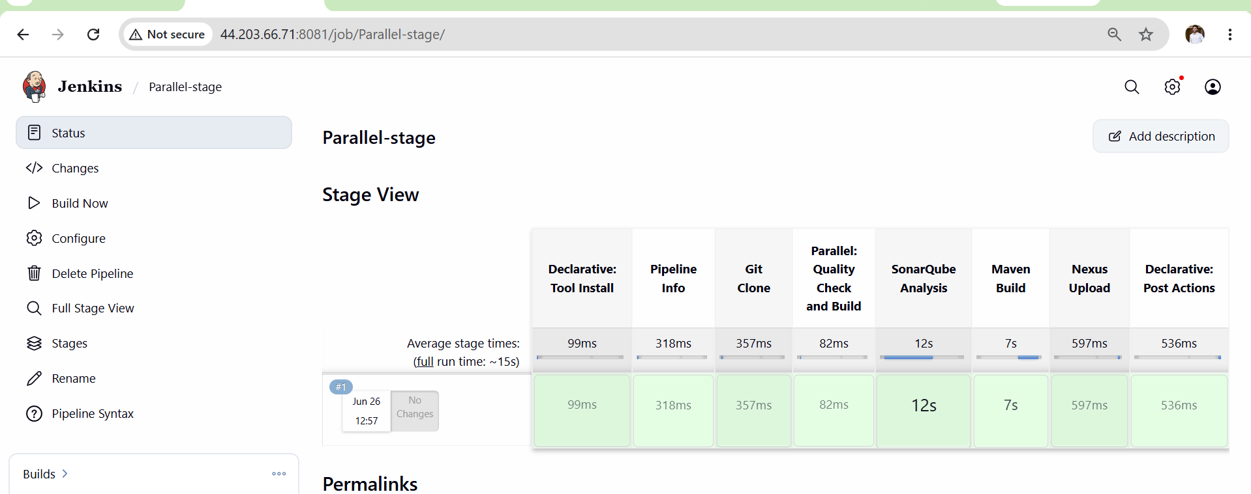

Nexus Upload
- WAR file visible in Nexus at:
http://44.203.66.71:8082
Browse → maven-releases → com/betawins/hiring-app/1.0/
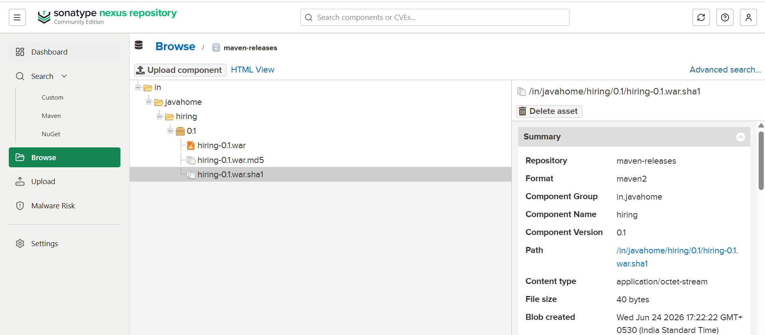
Slack
- Success message received in Slack channel:
SUCCESS : Hiring App MultiStage Pipeline Completed
Build: #1 - Job: Hiring-App-MultiStage-Pipeline

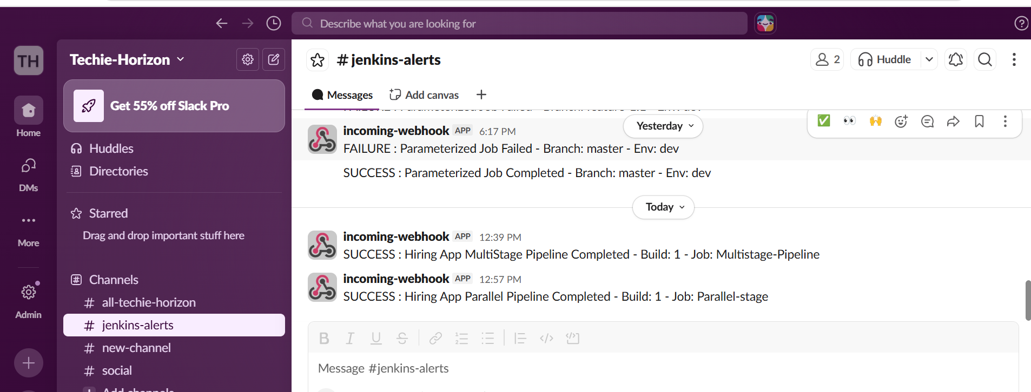

Outcome
- A Jenkins Multi Stage Pipeline job created and running successfully
- All 5 stages visible and green in Jenkins Stage View
- Code cloned from main branch of hiring-app repository
- SonarQube analysis report generated and visible on dashboard
- WAR artifact built by Maven and uploaded to Nexus repository
- Slack success notification received on pipeline completion

